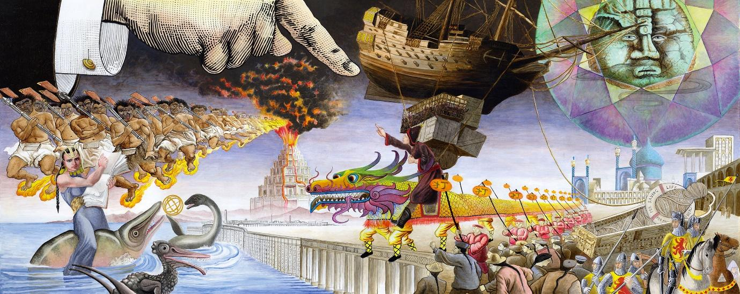Image 1: Painting by David Normal (2014) entitled ‘Curiouscillotropy’ meaning ‘to follow the oscillations of thought’. The painting uses and remixes images taken from digitised books from the 19th Century made available by British Library Labs on Flickr Commons. The painting is one of four which were transformed into large illuminated lightboxes as part of the Crossroads of Curiosity exhibit at the Burning Man Festival at Nevada, USA (2014) and the British Library in London (2015).
The Cultural Remixing Mindset and Digital Cultural Heritage
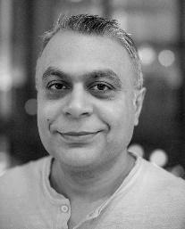
Image 2: Mahendra Mahey
(This is a long-read article with an estimated read time of around 30-40 minutes)
Mahendra Mahey is a Senior Research and Development Specialist at Tallinn University, a Junior Researcher at the Estonian National Museum in Tartu, Estonia and a PhD candidate at the University of Strathclyde, Glasgow, Scotland.
Mahendra works as part of the Digital Cultural Heritage as a Resource for Social Development project, and gave a talk in August 2024 at a workshop organised by the project at the Estonian National Museum. He spoke about creative uses of digital cultural heritage and how he has helped engage researchers, artists, educators, entrepreneurs and the public to access, use and more importantly reuse, experiment and remix British Library digital cultural heritage through new and exciting projects. He told the story of how he set up and ran British Library Labs (BL Labs) at the British Library (BL) in London from 2013 to 2021, the first digital cultural heritage Laboratory at any large National Library in the world.
Mahendra not only has a passion for making digital cultural heritage openly accessible and visible for everyone but also for people and computers to access, use, reuse, remix and recycle digital cultural heritage in new ways, often creating new culture along the way.
What is the first thing you associate with digital cultural heritage?
This is a difficult question to answer because I think there are many ways to answer the question. My answers would depend on the perspective and mindset I adopted and at what time that question is or was being asked. Secondly, the question begs an answer to another question first, namely ‘What do I understand by the term ‘digital cultural heritage?’, or perhaps even before that, ‘What do I understand by cultural heritage more broadly?’.
What do I understand by cultural heritage?
Cultural heritage for me is what is left and preserved so that people of today can experience the physical and non-physical remnants of humans that lived at a particular point in time, in a specific place or places in the past. These cultural fragments may capture people’s history, memories, experiences, feelings, what they believed in, what values and attitudes they had, what kind of communities, groups or societies they lived in, basically some remnant of who they were. Cultural heritage can build a bridge between the people of the past who are (by and large) no longer here and people who exist now. Cultural heritage can inspire, educate and inform people of today and the societies they live in and influence what they may do in the future. Engaging with cultural heritage is a form of time travel into the past and the future.
Examples of physical or tangible cultural heritage could be things such as books, diaries, ornaments, cooking utensils, art, places they lived, buildings, villages, cities and even the natural surroundings they inhabited.
What is perhaps more difficult to preserve and provide access to are things that are ‘intangible’ such as stories, sayings and songs in a culture, especially if they were never written down and/or only passed down through oral traditions for example. Other intangible cultural heritage could be dances, music, ceremonies, skills, healing sickness with herbal knowledge, beliefs about life etc.
What do I understand by Digital cultural heritage?
Digital cultural heritage can be digitised forms of physical (tangible) and non-physical (intangible) cultural heritage such as the digital capture (digitisation) of art, books, music, photographs, historical newspapers, performances, music etc.
Digital cultural heritage can also be born digital first, meaning that the cultural heritage was created digitally originally using digital technology such as cameras, scanners and media recorders for example. Examples of born digital cultural heritage could include art, photographs, computer games, music, interactive fiction, books etc.
Preserving and providing access to digital cultural heritage can be very challenging, as digital technology changes so quickly, meaning previous digital file formats and platforms can become rapidly obsolete.
Accessing tangible and intangible cultural heritage can help us understand, relate to and even learn from the culture of the people it came from and teach us about ourselves. It can represent lessons from the past so that we can live in enlightened social groups and build better societies for the future. As the famous reggae music artist Bob Marley said in his song ‘Buffalo Soldier’:
‘If you know your history, then you would know where you coming from’.
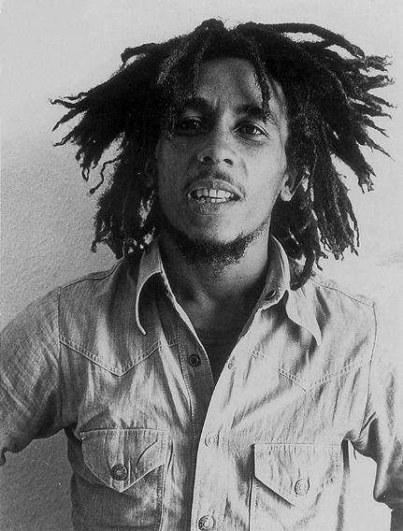
Image 3: Reggae music artist Bob Marley (picture taken from Wikimedia Commons)
I would argue that cultural heritage is vital for us to understand where we came from and who we are.
Accessing digital cultural heritage
Places which keep cultural heritage are for example Galleries, Libraries, Archives and Museums (GLAMs) as well as other institutions such as universities, companies, hospitals, manor houses or even the homes of private individuals. All these organisations play an important role in connecting us to cultural heritage of the past.
Depending on permissions, it is often easier to access digital cultural heritage today if it is made available freely online through a web browser. This means people may not need to take a trip to the institution to ‘experience’ the original physical cultural asset (especially if it was digitised). Often, experiencing the cultural artefact ‘digitally’ can often inspire us to then want to make the trip to see, experience, feel, empathise with and even smell the original real physical artefact it came from (i.e. activating many more senses, thoughts and feelings).
Many institutions provide access to digital cultural heritage, both digitised and born digital content such as obsolete web pages, computer programs, digital photographs, video and music.
Digitisation and making digital collections available onsite and online represent a huge investment of time, money, resources and energy for an organisation. I argue that digitisation is a worthwhile activity because often only a small fraction of what is on the shelves and in the boxes in the world’s GLAMs is available online.
At the BL, much digitisation activity tended to be funded through philanthropic and commercial means and much less via taxpayers. As a result, an estimated 3% of the BL’s physical collections were digitised, which means what is digitally available might not necessarily seem comprehensible and consistent to users when compared to the BL’s vast physical collections (over 170 million items, with only 9% of these books). Of these digitised materials, only around a third of them were available openly online, the majority were still only accessible physically on site even though they were in digital form. The reasons for this are many, but some focus around not having considered licensing thoroughly enough at the point of digitisation and / or the lack of resources, motivation or push to make them available openly. Whilst many other institutions are not as large as the BL, most that contain historic materials, especially those that were established in the pre-digital era, only have a fraction of their physical archives digitised and even less of these are openly accessible.
I am a strong believer that cultural heritage organisations have a responsibility and a civic duty to provide as much access as possible to everyone to experience and learn from the cultural heritage, including the digital heritage they look after. At their core, GLAMs and people working in them should try and make that connection and impact with others through the cultural heritage they curate.
So right now, the first thing I associate with digital cultural heritage is making it accessible and visible so that it can be used and not ignored and secondly and perhaps more importantly I associate digital cultural heritage with how can it be reused, remixed and experimented with to ultimately leave a positive impact on people, groups, communities and society inspiring, entertaining, educating and informing them.
How developed is this area in Estonia at the moment?
I would like to answer this question in two ways, ‘How developed is Estonia in making Digital cultural heritage available?’ and secondly ‘How developed are Estonian institutions in encouraging people and computers to reuse and remix digital cultural heritage?’.
How developed is Estonia in making digital cultural heritage available?
Ever since I moved to Estonia, I have been curious about Estonian digital cultural heritage. I would say that from my impression most large cultural heritage institutions in Estonia seem to be pretty good at providing online access to some of their digital cultural heritage. Institutions provide descriptions of what they have, be it in physical and digital form (metadata) and in some cases Estonian GLAMs provide access to their digital cultural heritage (both digitised and born digital) to greater or lesser degree.
If people are interested in digital cultural heritage, then it seems possible to access and use online portals from the GLAMs, if they are aware of them, either directly from the institution, or through search engines. For me, it seems that most interfaces for accessing digital cultural heritage in Estonia are mostly used by specialists and those already motivated and interested in cultural heritage. I must say that many of these online interfaces are showing their age and look a bit ‘tired’.
Estonia is a relatively young and small country. In my opinion, Estonians are still figuring out their identity. This is especially true given Estonia’s complicated history of colonisation and understanding of what the impact this had on what it means to be ‘Estonian’ be it through historical German, Russian, Polish, Swedish or Danish influences. When I ask Estonians what it means to be Estonian, they often say two things, the language, and nature. I have a feeling that it is much more complicated than that.
The National Archives of Estonia has an impressive 10 million records, 150,00 maps, 9.5 million meters of film records, 1 million photographs and around 35 million digitised images (representing around 5% of their collections). Access to many of these digital collections is through their Virtual Reading Room (which does require a login, which is a small barrier in my opinion). Once you are in, you can get access to currently 32 different kinds of databases (as of 2025). For me, I am particularly interested in MediaTeek which provides access to Estonian Photos, Films and Sounds, with some images available on other platforms such as the National Archives of Estonia Flickr Commons site.
The National Archives of Estonia have been experimenting with machine learning and Artificial Intelligence. There have been some interesting experiments with images using the FOTIS database, such as computational object recognition in images using the coco dataset library to algorithmically recognise and tag objects in pictures, This information is added to the image records which then in turn hopefully improves search and discoverability of that cultural asset.
Perhaps my favourite service from the National Archives is a service called ‘Ilme’ where you can upload a picture of yourself or someone else. The tool then uses Open CV to find the best match against half a million digitised photographs containing 3 million faces dating back to 1840. ‘Illme’ in other words enables you to find out if your face matches or is similar to someone in the digitised archive. This is a nice way for the public to engage with digital cultural heritage.
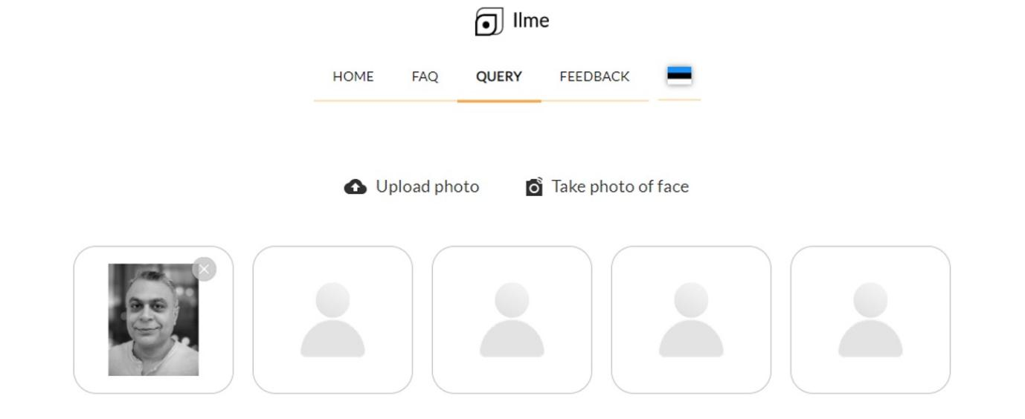
Image 4: Submitting an image to the Illme interface
‘Illme’ allows you to upload an image of a face and see if it is like one of the digitised images in the archive. Once requested for a similarity check, you are emailed a likeness within 24 hours of uploading your image, see below:
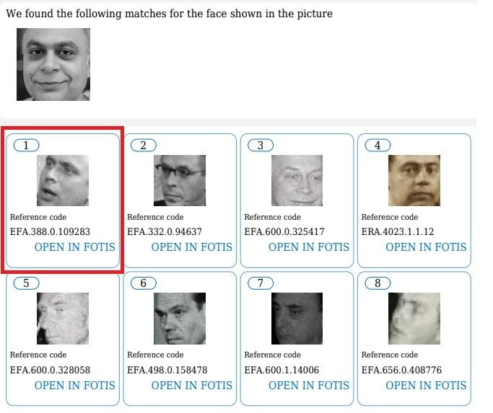
Image 5: Getting the results back from ‘Ilme’ via email (in total there were 161 matches to my face, the first entry highlighted in a red box is the closest match)
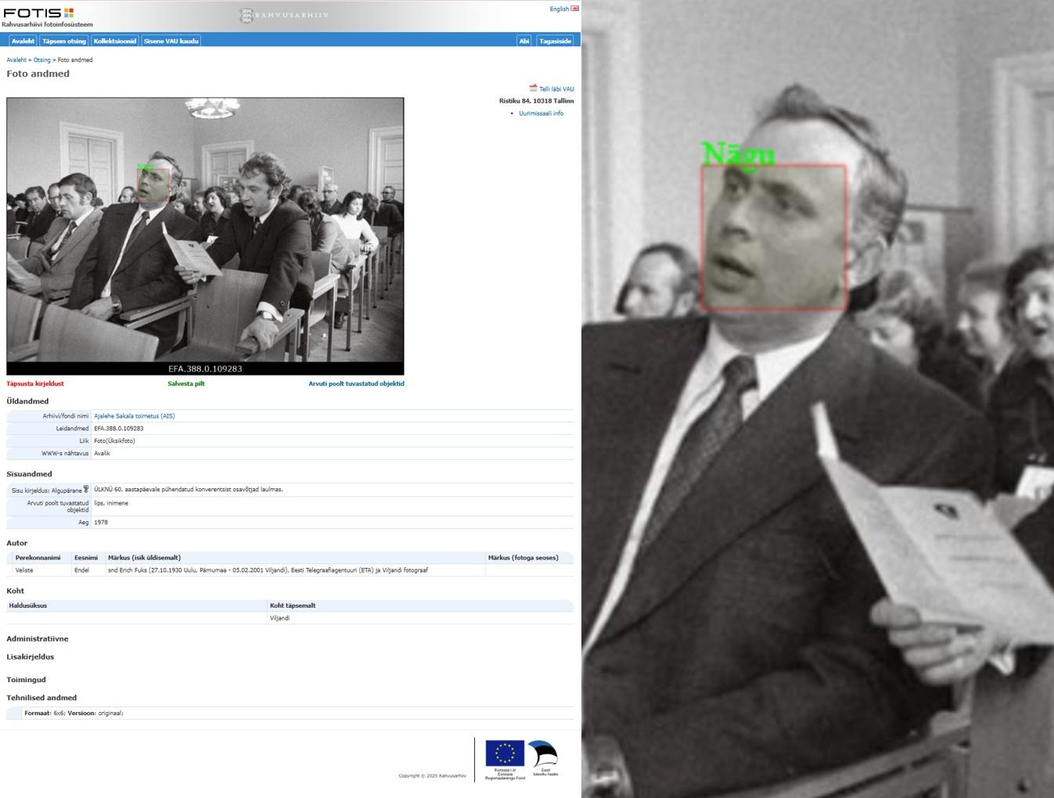
Image 6: The most similar image to my face in the National Archives of Estonia image repository (FOTIS)
Another service from the National Archives is called Transkribus which enables users to search through digitised manuscripts of handwritten text (Minutes of Tartu City Council (1902-1940), Petitions to the Governor General of Estonia under Swedish rule (17th Century) and Russian Orthodox Birth Registers (1838-1938)) which I think is a great way to make an archive more accessible.
There are also a number of crowdsourcing initiatives from the National Archives such as Court Files and the Estonian War of Independence where the public have been helping to add information to records to improve their discoverability.
There is of course the Estonian Museums Public Portal or MuIS which contains records from an astonishing 71 museums across Estonia, in three languages Estonian, English and Russian, including the National Museum of Estonia. Often MuIS provides access to a digitised version of a museum object (almost always an image).
I was surprised there were so many museums in Estonia using MuIS. However, I later learned that there are at least 100 more, 171 museums at the last count, and I am sure this is still not the correct figure. For such a small country, I find this number staggering and it is clear many are making great efforts to preserve and provide access to the cultural heritage they curate. On the other hand, I wonder how financially sustainable it is to keep nearly 200 museums in existence for such a relatively small country of 1.4 million people? Many of the smaller museums do not provide access to their records or digitised/born digital items online and I wonder if this will ever be a realistic goal, given the cost and time investment needed. My instincts tell me that many museums’ collections will be absorbed into larger GLAMS over the long term.
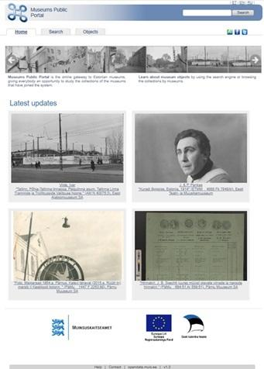
Image 7: The Estonian Museums Public Portal or MuIS stores records and sometimes digitised items from 71 Museums in Estonia (as of 05/02/2024)
The interface highlights/features images in the database through a scrollable banner ‘Latest Updates’ at the top of the home webpage which is a commendable way to shed a light on some of the material contained within MuIS.
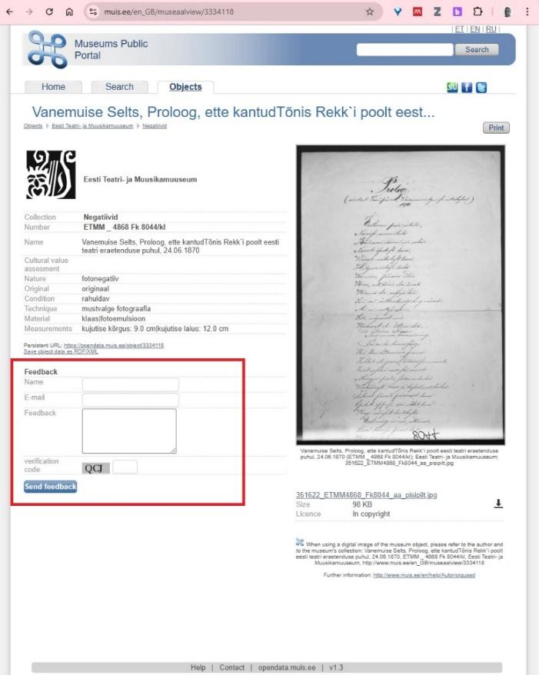
Image 8: MuIS user interface allows users to interact with individual records by giving feedback (highlighted in red above)
MuIS has an interesting open data feature which provides machine readable access to the records and digital cultural heritage it stores. This is a great if yet under-utilised feature, as I am not aware of large reuse of MuiS open data. I am hoping this might be explored further in the Digital Cultural Heritage as a Resource for Social Development project.
Clearly there are a large amount of interesting digital cultural heritage artefacts in MuIS, but a new modern, fresh interface would help a lot in terms of attracting new users.
I would like to put some attention on the work of Estonian Wikimedia Commons and Ivo Kruusamägi who has been ensuring that some Estonian digital heritage is also available on this platform. The Estonian Wikimedia community have also been carrying out educational outreach to different communities in Estonia, which is very commendable activity to increase engagement with digital cultural heritage.
DIGAR’s collection of Estonian articles provides an online portal for all digitally created or digitised newspapers, journals and other serials that are published abroad in Estonian or in Estonia which is another great but (I feel) under used resource. More innovative ways could be developed to get this content more visible and used and the Estonian Internet Archive is great resource that has great potential to be reused and remixed through projects. Then there is the Art Museum of Estonia’s Digital Collection portal that though requiring registration and login to see some the digitised artwork, much of which is restricted in resolution and rights access has potential for reuse and remixing.
When I was working at the BL, I came across Sift:Pics in 2015 by Vahur Puik, Lauri Elias and Maert Haekkinen which was a crowdsourcing application for digitised historic photographs where users could categorise digitised photographs. Siftpics is not live anymore, but a related project still is, Ajapaik.
For me Ajapaik is a superb example of how to make photographic digital cultural heritage accessible to a contemporary audience through a modern user interface and what seems at a relatively low cost. The interface allows users to tag and engage historic photographs, view them in different ways such as their geographical location and a machine interface to interrogate and grab thousands of images.
The work of Vahur Puik who leads the development of Ajapaik particularly needs acknowledgement and recognition. I wish that more Estonian GLAMs had similar user interfaces for their digital cultural heritage, for me it really is exemplary:
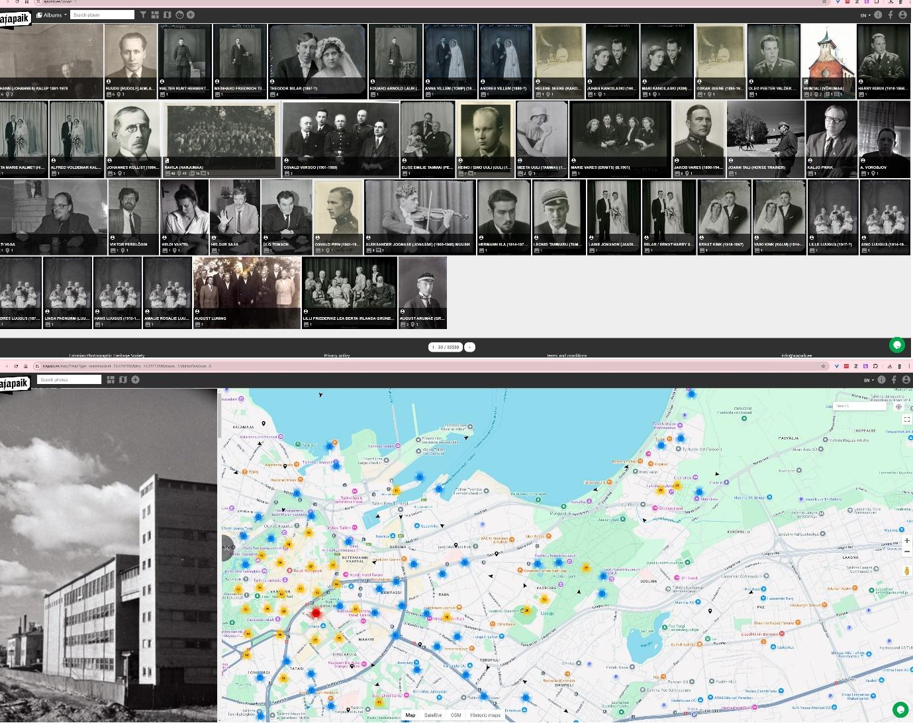
Image 9: The superb Ajapaik user interface, grid view (above) and map view (below).
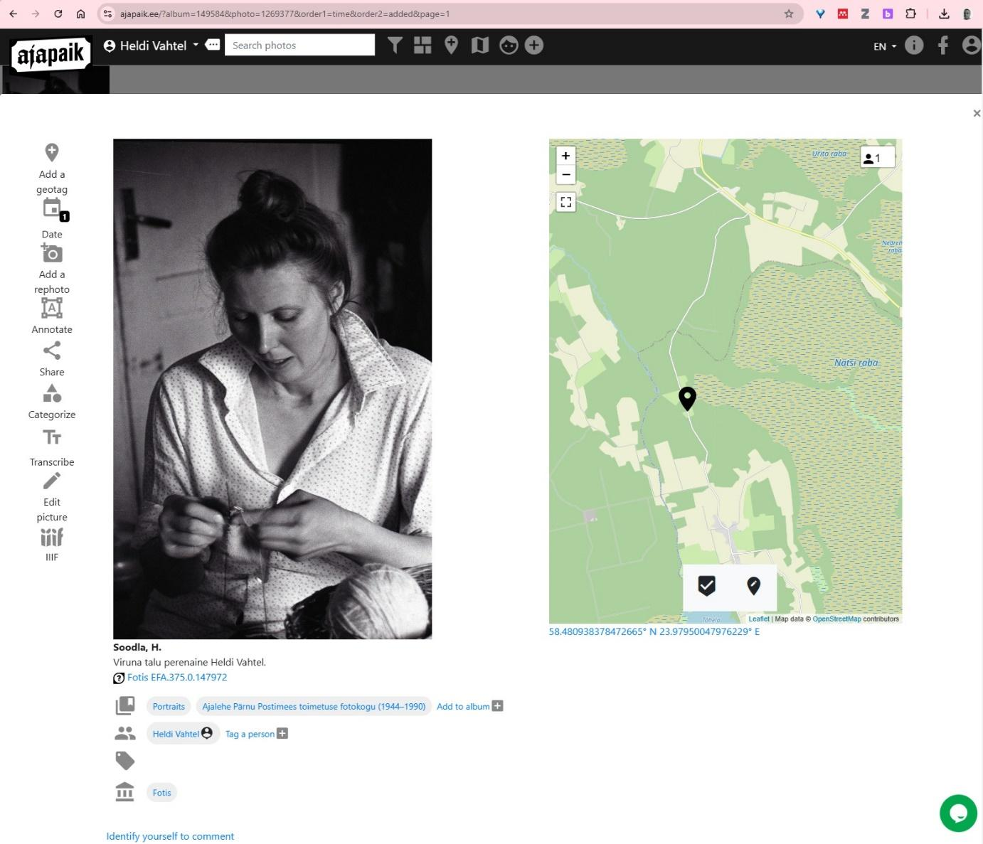
Image 10: Aijapaik’s individual photo page, includes the geographic location of where the image was taken. The interface allows the user to interact with the image by adding their own information such as: tagging a person, adding geotags, dates, adding a rephoto, annotation, categorisation, transcription and an International Image Interoperability Framework (iiif) version to display the image (providing a machine readable interface).
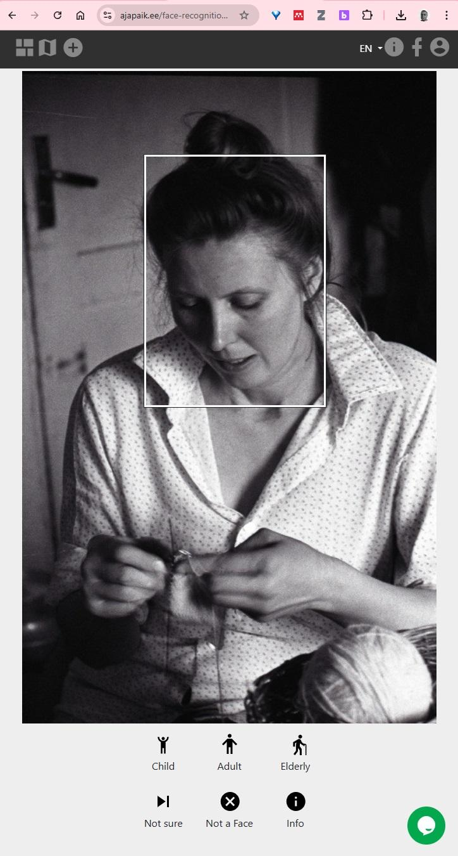
Image 11: Ajapaik’s feature for users to categorise faces.
How developed are Estonian institutions in encouraging people/computers to reuse and remix digital cultural heritage?
I would argue that this an area Estonian institutions is very underdeveloped. I would say that even after more than 10 years of setting up and running a digital cultural heritage Lab to encourage reuse and remixing of digital heritage, there has been modest progress across the world in this area. This is something I am exploring further in my PhD as to the reasons why this may be.
Though Estonian GLAMs do quite a good job of making Estonian digital cultural heritage accessible for people, there is still much room for improvement. Areas such as creating better user experiences and finding new ways to increase the motivation for people accessing and discovering digital cultural heritage are areas there could be much more attention on.
Many GLAM institutions may feel that they are doing enough by providing online access to digital cultural heritage though their online portals and therefore they feel they do not need to do anymore. Providing access to digital cultural heritage especially is a basic form of the use of cultural heritage after all. This is indeed an important aspect of what a GLAM should do as a minimum, however I think GLAMs can and should do more.
GLAMs need to find ways to get users to be inspired enough to want to reuse and remix digital cultural heritage to create new culture, to win their hearts and minds as to the value of doing this. Getting users to reusing and remix digital cultural is an ongoing process which requires attention and investment from the GLAM. One could argue that what is the point of spending money on digitisation and capturing and preserving digital cultural heritage, and then providing access to it if no humans are using it?
The step of getting users engaged, interested and wanting to experiment with digital cultural heritage is not easy. It requires a lot of effort and energy and this what a lot of my work at the BL focused on, namely developing a Lab structure and mindset for people willing to play with digital cultural heritage. This is especially harder to do when there is so much competing for people’s attention these days. It should be noted that the interested audience in specific cultural heritage (e.g. diesel trains) is likely to be quite a small percentage of the population and GLAMs should accept this as part of their strategy in engaging with potential users of the cultural heritage they curate.
I think the Digital Cultural Heritage as a Resource for Social Development project is an attempt to understand the extent to which institutions are doing this and it may discover what is the appetite, desire and capacity in society to reuse digital cultural heritage.
The Estonian Maritime Museum is working on an interesting ‘Living Lab’ project called ‘RECHARGE’ which is looking at new ways to engage communities with digital cultural heritage. The Living Lab is a user-centered innovation space that integrates research and innovation based on the idea of co-creating innovation with citizens and other types of users. This could offer some fresh ideas and models of how to engage users with digital cultural heritage.
The National Library of Estonia’s DigiLab, established in 2023, provides access to some digital cultural heritage in the form of datasets (where people can have access to thousands of objects in one go) hosted on the Zenodo platform, https://digilab.rara.ee/en/datasets/ for users to experiment with. The service seems is largely focused on working with Digital Humanities Scholars and Computational Linguists.
I visited Ryoji Ikeda’s Solo Exhibition at the Estonian National Museum in January 2025, and some of the art work includes remixing and using data from the Institute of Genomics, the Estonian Biocentre and a sound collaboration with the Estonian Philharmonic Camber Choir.
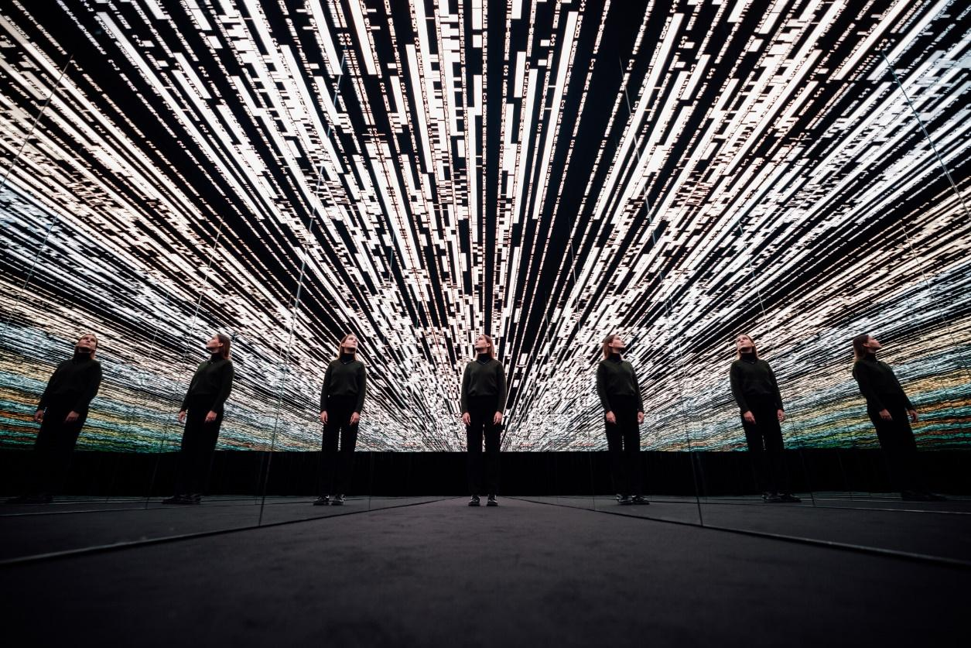
Image 12: Ryoji Ikeda’s audiovisual installation “the critical paths” uses the DNA data of people who live and have lived in the Estonian territories to illustrate the evolutionary history of the human species. Photo: Maanus Kullamaa / Tartu 2024
What kind of good practices from the world or of yourself could you highlight in encouraging people/computers to reuse and remix digital cultural heritage?
I believe there are a number of good practices I could highlight through the work I did at BL Labs, and I am able to showcase other examples around the world.
Good practices from my work at BL Labs
Getting the BL’s digital cultural heritage reused, remixed and experimented on by others and making sure there was evidence of this use was no easy thing to do and was very much the focus of my work at the British Library.
The GLAM Labs Recipe Book
Much of the wisdom that was gained over the years of myself and others working in GLAM Labs which encourage experimentation with digital cultural heritage was published in a book, ‘Open a GLAM Lab’ in 2019. The book was also made available in 7 languages, English, Arabic, Spanish, Greek, Serbian, Bulgarian and Russian.
The book is essentially about how to set up, run, maintain and ensure that a GLAM Lab flourishes, it even contains a recipe on how GLAMs can prepare digital cultural heritage as computational friendly data. The book is a kind of handbook or recipe book to dip into from time to time, and it’s packed with useful advice, inspiration, examples and case studies for organisations who want to get their digital collections used more or even to just adopt and encourage experimental practice with users and digital cultural heritage. The book may also be insightful for potential users who would like to work more closely with GLAMs and the digital collections and data contained within them.
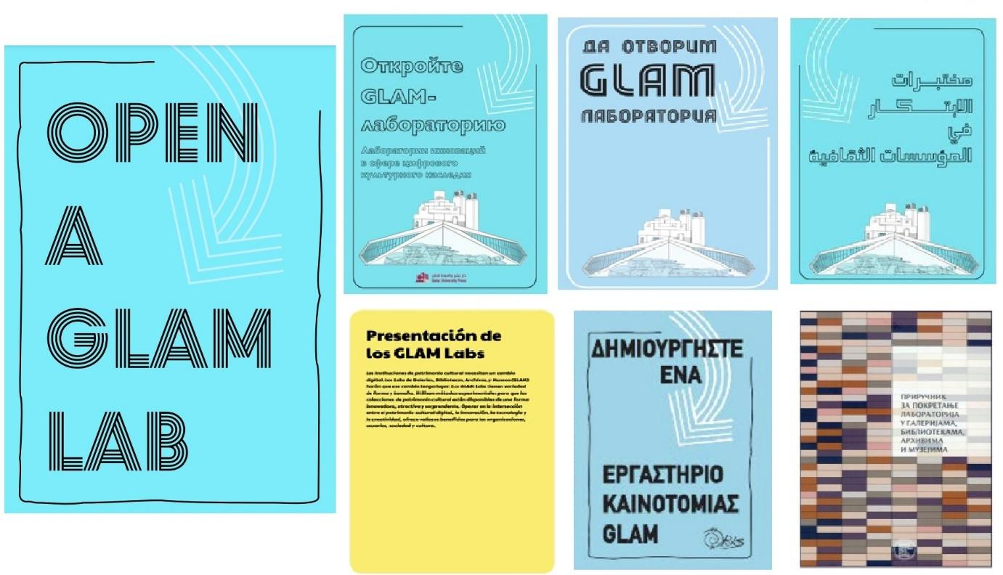
Image 13: Open a GLAM Lab was created through Digital Cultural Heritage Innovation Labs ‘Book Sprint’ which took place in Doha, Qatar, 23-27 September, 2019 and was released under Public Domain License.
The GLAM Labs community
The energy and effort that was required to create 'Open a GLAM Lab' also led to the development of an international GLAM Labs community which I helped establish. Currently (as of 14-02-2025) it has 354 members from over 90 institutions supporting each other through regular meetings, a mailing list and other communication channels. The aim of the community is to connect GLAMs which encourage experimentation and innovation on-site and on-line with digitised and born digital collections and data, promote the publication of GLAM digital collections and share best practices and guidelines.
Finding funding for your Lab
Creating an experimental digital cultural heritage Lab at a GLAM is a great way to focus on the activity of encouraging people to reuse and remix digital cultural heritage, i.e. having people who are specifically employed and dedicated to set up services for others to experiment with digital cultural heritage.
In the BL’s case, funding was needed to find up to one part time and two full employees to work on the Lab and provide other resources such as infrastructure for storage, tools, engagement activities such as events, travel, workshops, competitions, residencies and awards. BL Labs had 4 rounds of grants from the Andrew W Mellon Foundation and financial support from the British Library between 2012 to 2021. After this, it became a permanently funded ‘business as usual activity’ of the institution through the business case / justification process. Finding grants and funds to support Labs’ activity can be a way to ensure that there are people whose responsibility it is to try and encourage others to engage and experiment with digital cultural heritage.
The role of a Lab is to inspire people and to offer a space for experimentation with digital cultural heritage and where possible to transform them into workable pilots. To act as a catalyst for transformative practice across the organisation and society harnessing the power and affordances of digital tools and technology. And by saying a ‘space’, I do not necessarily mean a physical or online space, I also mean it needs to be a space inside our minds.
When I first came to Estonia I talked about some of my experiences in an article in the SIRP newspaper in May 2020 when I was interviewed by Aija Sakova, entitled “Telling meaningful stories and changing the mindset”.
Knowing the background story to a digital cultural heritage collection
Knowing the ‘history’ or ‘story’ behind a digital cultural heritage/collection helps when it comes to making it more visible to the outside world. If you can get the curator of the digital collection on board to tell you the story, it’s even better, as they can become an invaluable asset and expert in helping you to understand the collection and can even help you promote and get others to work with the digital material. What I learned is that the story behind a collection (especially a digital collection – for example what was digitised or captured) is full of subjective biased human decisions often made over hundreds of years.
Eating your own dog food/ Practice what you preach
To have credibility about encouraging others to the value of remixing and reusing digital cultural heritage it was important that the BL Labs team conducted its own experiments as well, to ‘eat our own dog feed’ or ‘practice what we preached’. It is much easier to convince others of the value of experimenting with digital cultural heritage if you are prepared to do it yourself, a simple but very basic lesson.
One of the first BL Labs team’s experiments was led by Ben O’Steen, technical lead for BL Labs, who employed computational methods to extract elements such as illustrations, maps and photographs from the pages of digitised largely 19th Century texts.
To make this collection visible, we created the Mechanical Curator, which published an image on a Tumblr blog and then used an algorithm to find and publish another 9 similar images from Flickr Commons collection.
Another experiment we conducted was around using face recognition algorithms from Open CV to try and distinguish between male and female faces in the images that were snipped out of 65,000 digitised 19th Century public domain books (which were largely illustrations).
In 2013, BL Labs placed over 1 million digitised images on British Library Flickr Commons and some digital items on Tumblr and British Library Wikimedia Commons. Where possible we put links back to where the digital cultural heritage assets were originally presented online from the GLAM. This created a ‘loop’ so that traffic can also be rerouted back to the home of the original place where the digital cultural heritage item was originally displayed (see example below):
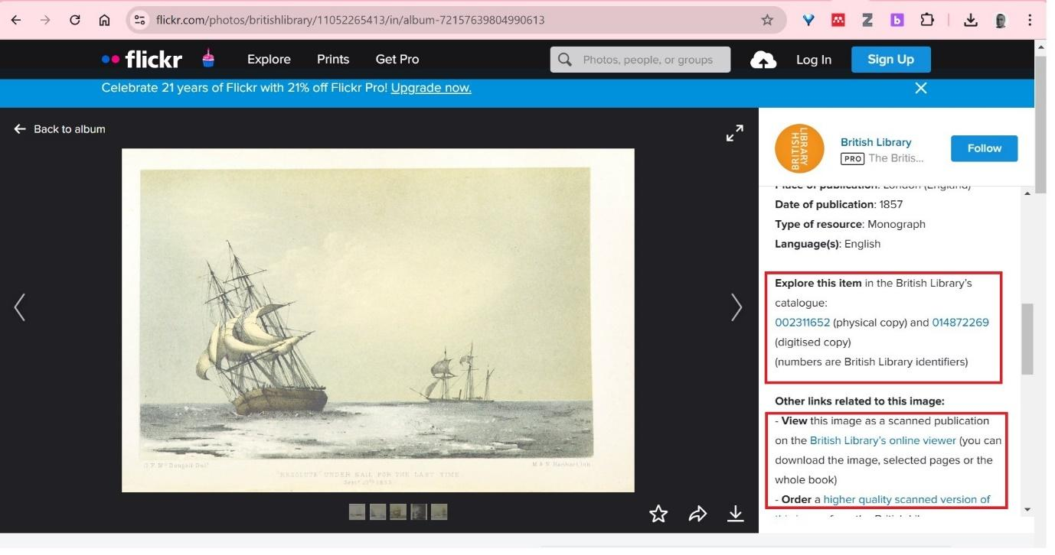
Image 14 – Example of a British Library Flickr Commons image page, shows how links back to the original catalogue are included when viewing the image (highlighted in red boxes).
There are of course other platforms such as the Internet Archive, Instagram, YouTube and TikTok which have been used by some GLAM institutions to put their digital cultural heritage, a practice which is still in its infancy in many ways.
Putting digital cultural heritage where users can find them
In the real world, the search behaviour of many people online is different to what memory institutions often assume. We cannot say that users would come as their first choice to the institution’s online portals to look for digital cultural heritage, in fact GLAMs are often the last place many look when they need cultural heritage materials. GLAMs need to accept this reality and instead think of other strategies to target potential customers with their wonderful digital cultural heritage treasures. GLAMs need to be humble and put their collections in the places where potential users tend to look daily and accept that many will still not be interested.
The counter argument to placing digital cultural heritage in several visible online places is that some may say it is not very efficient, perhaps not sustainable and environmentally sensible. This is a dilemma for many GLAMs, whether to put digital cultural heritage in multiple places so that they get noticed, or not? If it is possible and not that difficult to do, then why not, what harm could it do would be my position.
At the BL, we found that this strategy worked as the digital cultural heritage items from one digital collection received over 3 billion views on Flickr Commons, way more than if they were on the traditional GLAM platforms they were first put on.
Search Engine Optimisation
Much of the cultural heritage of the past still goes unnoticed by people today, even if institutions have provided free access to their digital cultural heritage online. It is a great challenge for GLAMs to know that people are aware of the cultural heritage they have. There is a huge amount of material and knowledge from GLAMs that simply doesn’t show up on search engines and therefore is invisible to many online. The reasons for this are many and complicated but a good start for GLAMs is to ensure their digital records and digital cultural heritage are visible to search engines such as Google and Baidu through search engine optimisation. Search engines are by far the most popular ways people access information today, especially in the western and eastern world where people have easy access to digital technology and the internet.

Image 15 (Google logo) and Image 16 (Baidu logo) – the world’s most popular search engines and where most people search for information online.
Getting people interested in digital cultural heritage is a great challenge for GLAMs, the digital attention space is ‘over crowded’ and people have increasingly shorter attention spans.
Promoting your digital cultural heritage curiosity shop
The digital collections of the BL represented a kind of ‘digital curiosity shop’ for me. It’s full of interesting and wonderful things waiting for someone to be inspired enough by them to make meaningful use of its digital offerings. Perhaps the digital collections may reveal new historical facts and discoveries or strange patterns, help tell new inspirational stories, be used to make new products or even help create new and provocative art. But first, potential ‘customers’ need to know the shop exists and know what’s in there. When that has been done, the hard job of trying to entice them in and use the digital collections begins! Fortunately, the BL had many things in digital form that were unique and intriguing and no one else on the planet had them.
I have always known instinctively that to get somebody interested in anything, it’s obvious that effort needs to be made to let them know that it exists first. At BL Labs, potential users were inspired with ideas as to how they could use digital collections, so that they could begin their own adventure in working with them.
After a number of years of hard work, I was able to show hundreds of examples of how digital collections have been used to inspire people to create new innovative projects. BL Labs organised numerous physical and online engagement activities such as competitions, workshops and meetings and social media campaigns to help in this endeavour.
I think it’s the role and responsibility of GLAM Labs and as many people as possible to help promote digital cultural heritage, be they working in the Lab, the memory institution or wider. For the BL, the National Library exists, to capture and inspire a nation's memories. If one person tells at least two others about the BL’s collections, and then these two tell two others and so on, you quickly create hundreds of opportunities to get people to know about and potentially access and use its digital cultural heritage.
In my view, publicly funded memory organisations have an obligation for their digital collections to be made openly accessible, with no restrictions for reuse. This, however, can create tensions within the institution that both serves public good and which can also be a commercial business.
Many of the BL’s collections were from all over the world and given my own Indian heritage I am very conscious that some of the reasons why they were there are partly because of the colonial history of the British Empire. I believe that providing open digital access to these materials can be a form of ‘digital decolonisation’, giving them partially back to their rightful owners, even if it is only virtual, it’s an important first step.
Collections as data
Institutions should find ways to ensure that the digital cultural heritage they make available online is also discoverable and readable by other computer programs. This is so that these programs can reuse and represent the digital cultural heritage they find and have harvested and consume it in other innovative ways and through other more visible channels.
GLAMs should follow the ‘Collections as Data’ movement which gives guidelines on how institutions can make their digital cultural heritage available as ‘data’ so that computers can make sense of it, consume it and perhaps represent it in new ways to users.
Treating digital cultural heritage/digital collections as ‘data’ and providing interfaces that are friendly and clean for computation (driven by humans of course) so that interesting things could be done with the data, such as find new patterns and make new discoveries is quite lacking or not very visible in Estonia. Following a checklist to publish digital collections as a data, the responsible datasets in context or datasheets for GLAMs initiatives may help Estonian GLAMs achieve this.
At BL Labs nearly 200 datasets (digital cultural heritage collections) were published through the institution’s digital repository available for reuse, remixing and experimentation.
Of course, I would also advocate that GLAMs use an Open approach to release their digital cultural heritage whilst also adhering to FAIR (Findable, Accessible, Interoperable and Reusable) and CARE (Collective Benefit, Authority to Control, Responsibility and Ethics) principles.
GLAMs being accessed by other computers for AI
I am particularly interested in users taking advantage of the fact these materials are in digital form and that they could access thousands of items in one go instead of one at a time. Harnessing the power of computation to carry out research on digital collections and data that would normally take humans hundreds if not thousands of years to complete. I explored how it would be easier to carry out computational experiments on onsite only available and open public digital collections through programming environments in web browsers such as Jupyter Notebooks, which avoid the need for users to download special programming software.
Many Artificial Intelligence programs such as ChatGPT improve the quality of information they provide users by harvesting greater and greater amounts of information from different sources (training data), GLAMs are an important source of data for this. Making digital cultural heritage computationally friendly data for harvesting is something cultural heritage should do more of. Though through recent interviews, I have discovered that there is some resistance from GLAMs because of some of the commercial drivers behind AI companies such as OpenAI. The term Responsible AI is something that is getting a lot of traction in the GLAM sector and something organisations such as GLAMs are thinking of adopting, see the National Library of Scotland’s Data Foundry AI Statement.
Amplification through Social Media and a ‘Post Truth’ world
Often, the information we receive through digital social media is biased, manipulated and sometimes just factually and historically inaccurate. We are increasingly living in a ‘post-truth’ world. Many malicious actors, dictatorial regimes, organisations and companies are trying to rewrite history and present their own view of the world. Whilst this kind of ‘propaganda’ is something that has happened throughout the centuries of human existence, digital technology seems to be a very powerful way to influence a large group of people relatively quickly, to supercharge influence and impact. Cultural heritage organisations need to be vigilant and constantly think of new ways to get even a small amount of interest towards their digital cultural heritage. They are competing against the many millions of things vying for our attention and trying to harness this amplifying effect where possible.
Organising Public Exhibitions for BL Labs
I am very proud to say that I was involved in the creation of 2 major art exhibitions through BL Labs inspired by the Flickr commons collections at the British Library. Crossroads of Curiosity by Burning Man artist David Normal (2015) and Imaginary Cities by contemporary new media artist Michael Takeo Magruder (2019) both were groundbreaking in different ways.
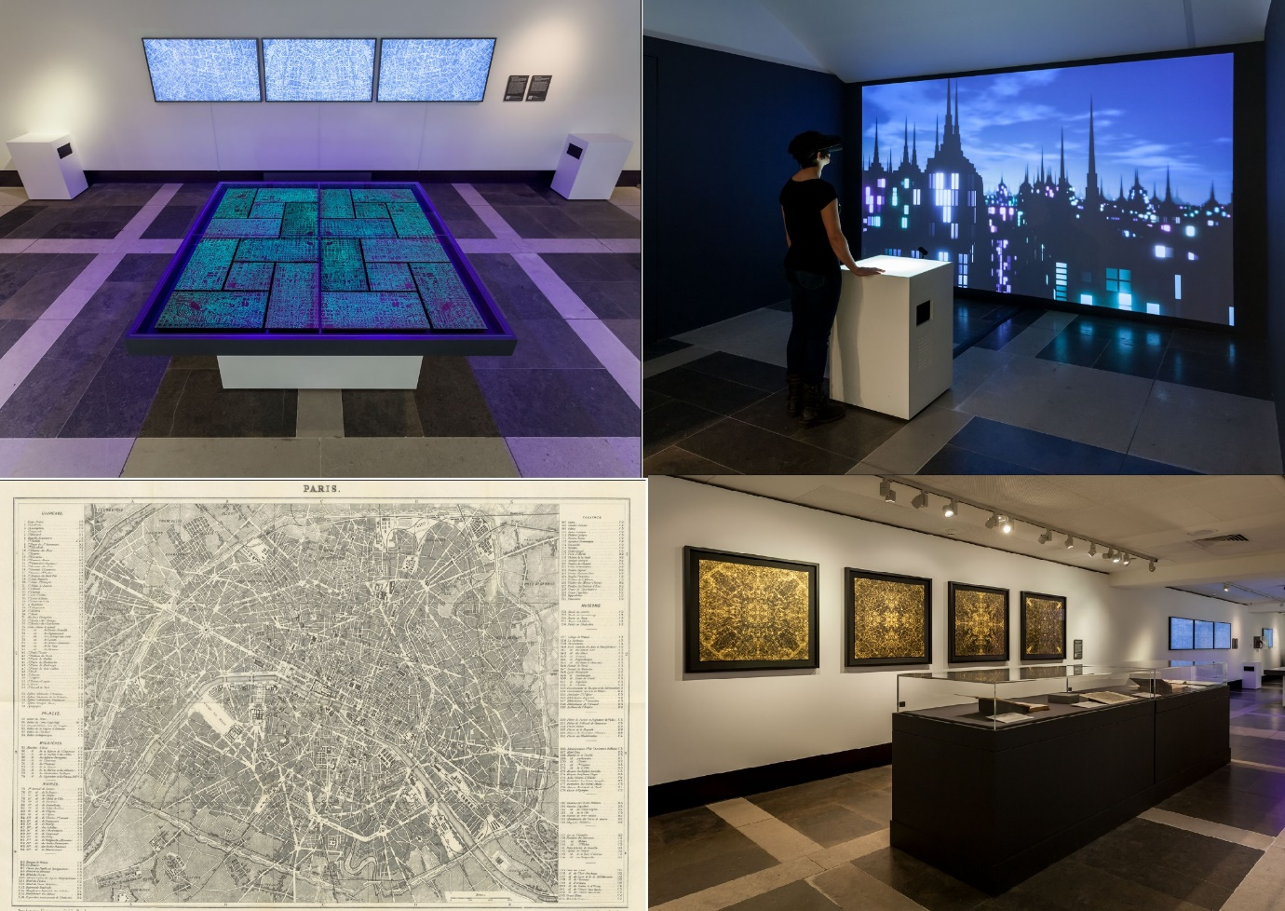
Image 17: Imaginary Cities Exhibition at the British Library by Michael Takeo Magruder (2019)
Helping to make these exhibitions happen involved a lot of personal sacrifice, hard work, determination and belief. Both exhibitions had hundreds of thousands of visitors onsite and online and created visible interest in the BL’s digital cultural heritage.
Engagement with staff within and outside the GLAM working with digital cultural heritage.
Though I was part of a very small team at BL Labs (at most 2 and a half people) it was important to have other advocates of what BL Labs was all about within the BL. This meant talking to curators, digitisation staff, IT specialists etc. and telling them about what BL Labs was all about so that they understood its mission and if they liked what they heard could then become ‘cheerleaders’ of the Lab.
Some senior staff were part of a steering committee for BL Labs which was responsible for some of the decision making that was needed when the work of the Lab impacted the work of the organisation, having this group also spread the word of the Lab.
What was also clear was there were many staff who were doing interesting things with the institutions’ digital cultural heritage. In 2015, I decided to set up an annual award for staff, for those doing innovative things with the BL’s digital cultural heritage. Over the years since, there were some fantastic projects, for example Hack Days organised by one department and the British Library Simulator.
BL Labs also had an external advisory board, which was responsible for some of the decision making that impacted external stakeholders of BL Labs activities. They also acted as external champions and amplifying the successes of BL Labs.
The lesson I learned is to find as many people as possible who believe in what you are doing so that they can also become the promoters of it to amplify the message.
Everything starts with a conversation - BL Labs roadshow, visits, meetings, listening to people and showing them the data.
It is wrong to assume that just because the institution made their digital cultural heritage available online through a web interface it means that people will know what is there. I spent a lot of time going out to institutions and talking to people, showing them the BL’s digital cultural heritage, debunking a few myths and correcting some misunderstandings about the BL.
I ran ‘ideas workshops’ which encouraged people to think of new ideas of what to do with the BL’s digital cultural heritage and of course I tried to inspire them with projects that had already used the digital collections.
Kinds of questions researchers asked about digital cultural heritage
Researchers almost always asked me if the BL had specific things amongst its digital collections that they were interested in. However, given that only a small proportion of the BL’s physical collections had been digitised, the chances that the BL would never have the exact thing they were looking for almost never happened! Instead, my answer tended to be, we don’t have what you are looking for digitally (we might of course have it in physical form), but we have this similar digital thing instead. This often required a shift in their thinking to re-think as to what they could do with this thing that they were not expecting to have before them. Understandably, this is often the point where I lost some researchers and that’s why getting people to engage with digital cultural heritage is such hard work. I would say that most of the research questions that researchers came up with focused on identifying, finding and looking for patterns in often incomplete messy historical cultural heritage data.
Exploring your inner Labber - failing fast, experimenting and piloting
At BL Labs I ran residencies, which invited researchers in to encourage them to play and experiment with the BL’s digital collections through a competition call.
We tried to offer a safe environment where people could test their assumptions of what they wanted to do with digital cultural heritage. One of the most important lessons I learned was that most potential users of digital cultural heritage make assumptions.
When they wanted to work on an idea, their ideas would almost always change once they had seen the reality of what was contained in digital cultural heritage collection they were looking at. Often the technology that was available to do the experiments that researchers wanted to do were limited and the researchers also had to often face their own limitations, i.e. not having the necessary technical skills to do the things they wanted to do with the digital cultural heritage. Often the digital collections were incomplete, they were not always described with enough information, and sometimes the digital cultural heritage simply didn’t have what the researcher was looking for. Researchers often had to change direction and ask a different research question to the one they originally asked. This new question may have provided a better chance of being answered because they now had more familiarity with the digital cultural heritage they were examining. A big lesson I learned was it’s important for researchers to get to know the data or have a ‘date with the data’ first. It’s a similar analogy to cooking, getting to know your ingredients, what is possible and what is not.
Allowing researchers to explore and experiment, make mistakes, have successes through pilots and where appropriate tell the world meaningful stories through the BL’s communication channels was often a great recipe and precursor to apply and be successful in getting future funding for projects.
Often what is happening during experimentation in the GLAM Lab, is something that happens a lot in entrepreneurship, which is called ‘failing fast, failing better’. I often found giving researchers restricted timescales to conduct experiments allows for a focus on the most important and achievable results, i.e. to develop a simple pilot/prototype, a minimal viable product or solution that could be scalable. Of course, working quickly often means people make mistakes and in certain situations compressed timescales are not appropriate. However, imposing a restricted time-period to conduct experiments can be a great ‘focuser’ of the mind in my experience to get researchers to understand the fundamental nature of the problem they are interested in.
One of the other things that often happens in the Lab environment is to ask researchers bold and at times uncomfortable but really important questions, such as ‘Why are you asking this?’, ‘What is the value of this question to humanity?’, ‘Why is this meaningful to a wider audience?’, ’Who cares about this work?’, “Is this research question really relevant to our society?” or “Does this actually need to be analysed via the help of computational methods?” Harnessing the power of computation can of course mean research questions are scalable, however sometimes it is good to know that the use of computers was not always a panacea for everything, there are still things humans are better at doing than computers (for now at least).
Most scholars reacted positively to experimenting and failing fast. I think many of them felt relieved that they were allowed to fail. I was offering a unique, safe and even anonymous place for researchers to fail, as often the institutions they work for or the societies they live in shun failure. Maybe some researchers were able to reconnect to their inner child or ‘labber’ (a labber is someone who adopts experimental methods) and enjoy the humility, joy and simply fun to be experimental and playful. I sincerely believe that everybody needs moments and space in their life when they should not take themselves too seriously and just have some joy and not be afraid to make mistakes, something common I would like to think as humans we all share.
I have learned and sometimes I need to be reminded of this again and again that ‘good enough’ is sometimes ‘good enough’ to get the job done. Striving for perfection means you will never succeed. I have often heard scholars say ‘Can I actually do that? Experiment and fail?’. My reply is, ‘Yes, this is what a GLAM Lab is for’.
There are some great examples other GLAMs doing interesting things with digital cultural heritage.
The National Palace Museum of Taipei has a great open data portal.
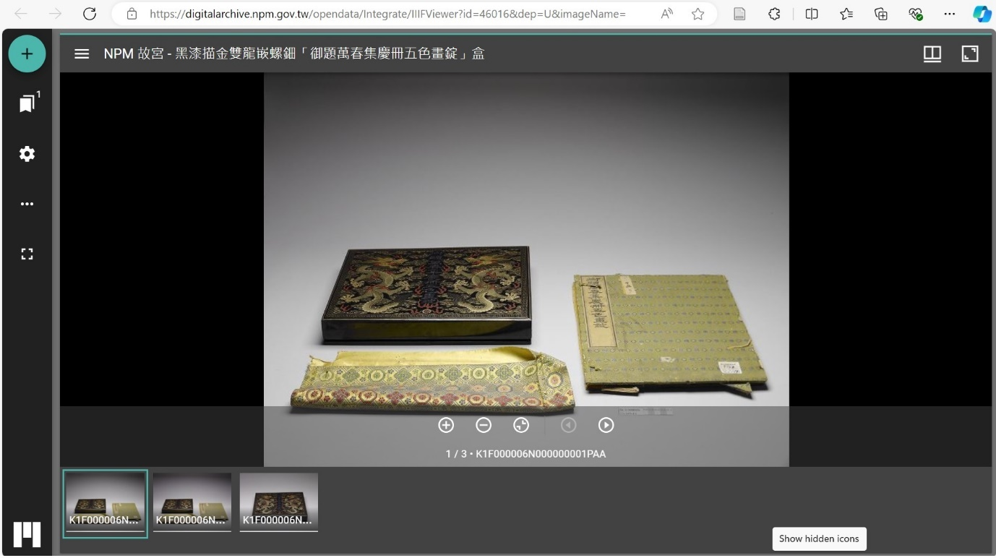
Image18: The Open Data Portal of the National Palace Museum of Taipei
The National Library of Scotland (NLS) has a digital scholarship service called the Data Foundry which encourages users to download and forge digital collections into new things through experimentation. The NLS organises an annual fellowship to encourage researchers to experiment with the NLS’s digital cultural heritage.
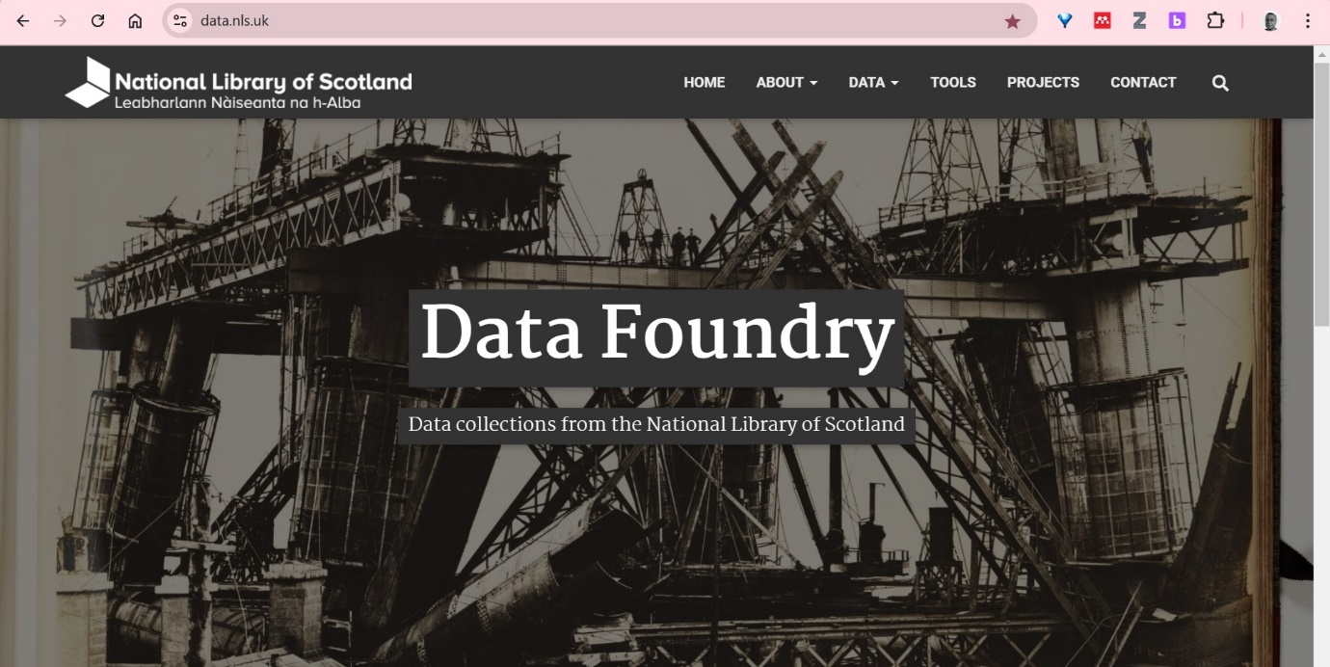
Image 19: The National Library of Scotland’s Data Foundry
The Metropolitan Museum of Art has created a simple yet modern looking user interface to their digital cultural heritage.
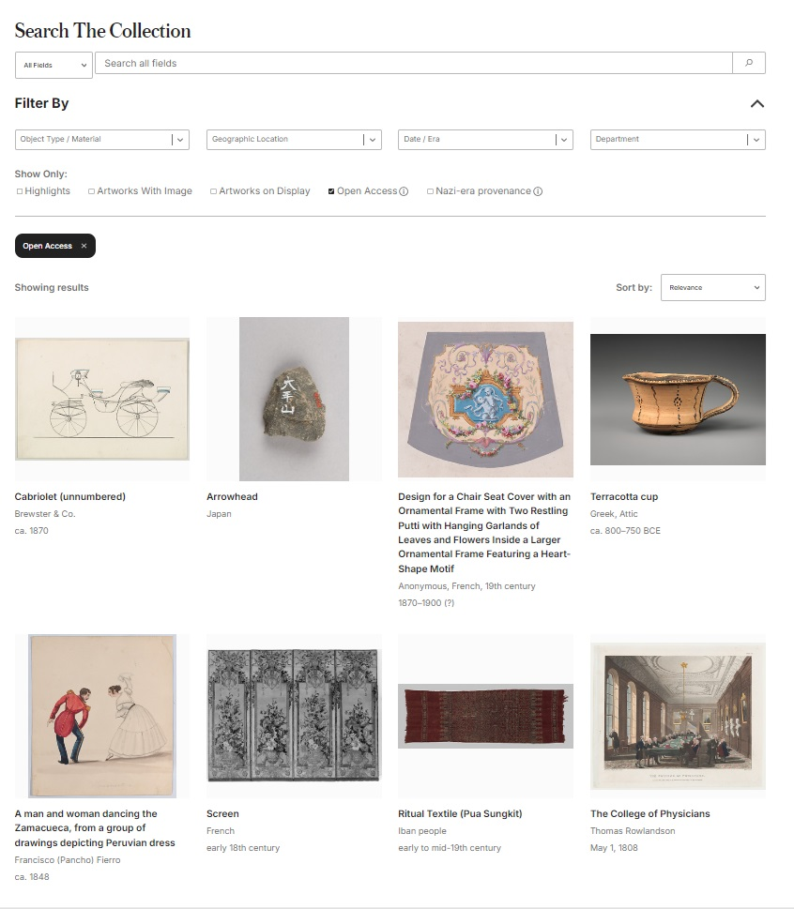
Image 20: Metropolitan Museum of Art Collection Interface has an impressive range of public domain images available to the public.
The Getty Research Institute has developed the Arches platform over many years to display and manage digital cultural heritage and the International Image Interoperability Framework offers a standard to display images from a GLAM which can be accessed automatically by other computers.
The Library of Congress Labs is now working on providing innovation through AI to the staff at the Library. ONB labs at the Austrian National Library does great work with digitised newspapers. KB Labs in the Netherlands and KB Labs in Denmark all do exemplary work in the GLAM Labs field. The National Museum Gallery of Finland have been running a generative art competition that uses the galleries openly licensed digital heritage and metadata called Combine 24.
The Royal Library of Luxembourg offer almost a shopping type experience when accessing their digital cultural heritage:
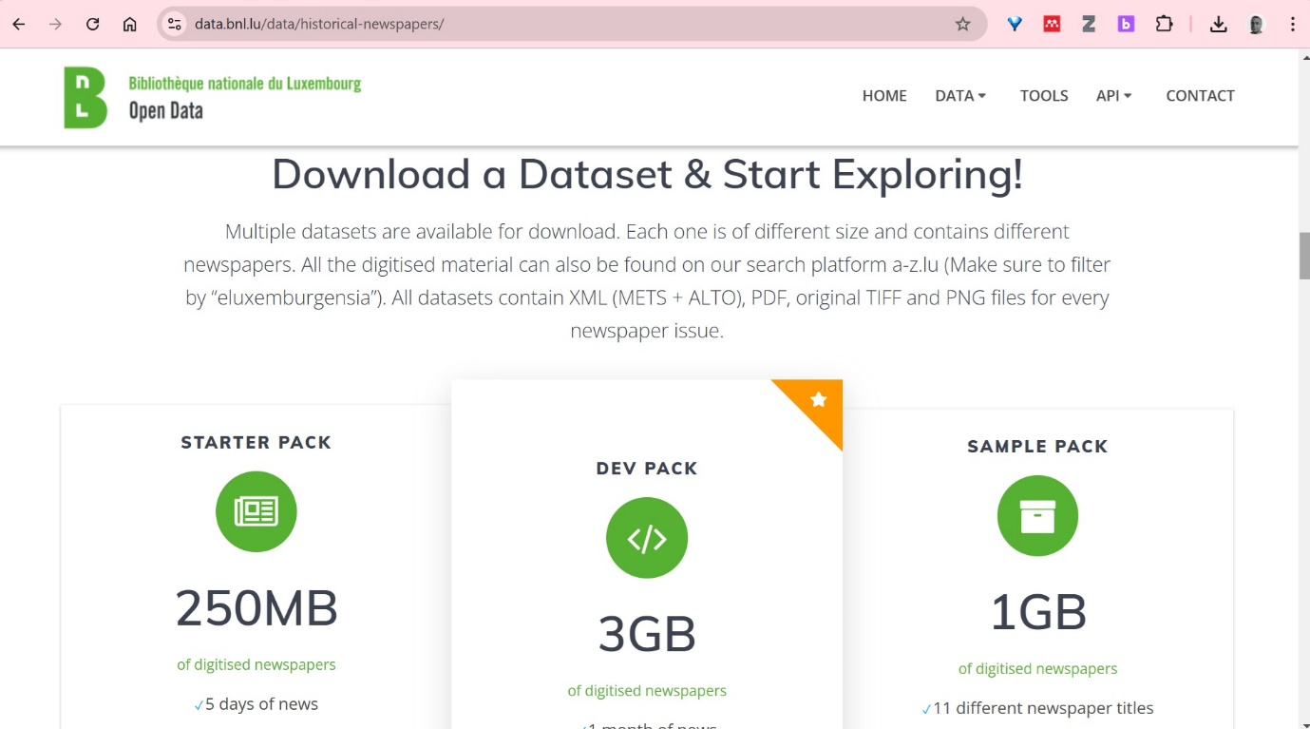
Image 21 – The Royal Library of Luxembourg’s shopping experience of providing access free access to their digital cultural heritage
Finally, I would like to reference the common European space for cultural heritage which is offering a European platform for access to digital European cultural heritage.
How can we make more use of digital cultural heritage in our lives than before, and what would society as a whole gain from it?
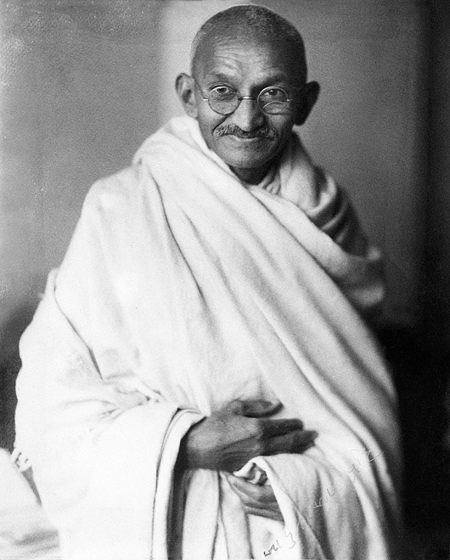
Image 22: Mahatma Gandhi (1931)
‘Be the change that you wish to see in the world’, Mahatma Gandhi
If we want to see more use of digital cultural heritage in our lives and in society it starts with each one of us. I believe that those working in this field should become champions and promoters of remixing digital cultural heritage (eat their down dog food or practising what they preach). By doing this they will understand how easy or difficult it is to do remix digital cultural heritage, and they can then communicate with others more convincingly on how others may work with remixing digital cultural heritage.
One of the best examples of practising what you preach is the work of Tim Sherratt and his GLAM Workbench, showing the power of one person and what they can achieve in the digital cultural heritage experimental field. It is noteworthy that many of the GLAM Labs initiatives around the world require a proportionally small amount of funding for often great reward.
GLAMs should invest in Labs which create safe spaces online or onsite to encourage the use, reuse and experimentation with digital cultural heritage. The Labs should have employees specifically responsible for making the connection with people and digital collections and encouraging a playful and experimental mindset amongst staff and users. Labs should have the philosophy to say that it is OK to experiment and fail with digital cultural heritage.
One way to engage people to experiment with digital cultural heritage is by organising competitions. This can give users psychological motivation and a concrete reason to want to use digital heritage in the first place, knowing that there could be a reward and recognition for their work once they have created something. This can create a ‘virtuous circle’ that others may want to join, a fear of missing out, a circle that celebrates and brings joy in the use of digital cultural heritage.
Another great initiative is crowdsourcing and citizen science projects which encourage the public to help to achieve a task that would be otherwise difficult to achieve for the GLAM. During my time at BL Labs we worked on several crowdsourcing projects. One of them was with a group of volunteers and programmers to identify and geo-reference 50,000 maps from a collection of images that were snipped out of 65,000 digitised 19th Century Books, equating to over 1 million images. Information about the maps was then placed back into the catalogue records of the books the maps came from.
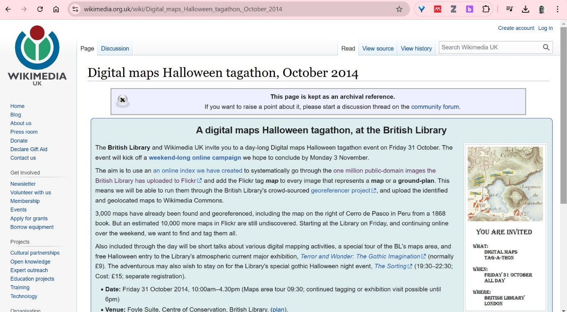
Image 23 – Digital maps Halloween Tagathon, October 204
As mentioned previously it is wise to update user interfaces of online portals for digital cultural heritage. They should be attractive and easy to search when presenting cultural heritage and digital heritage records and allow users to interact with them and add their own additional information if possible. Much of the digital content should be made available under open licenses if possible.
The Rijksmuseum offers access to over an interesting interface to their over 840,000 digital cultural heritage items which are mostly freely available under a public domain license:
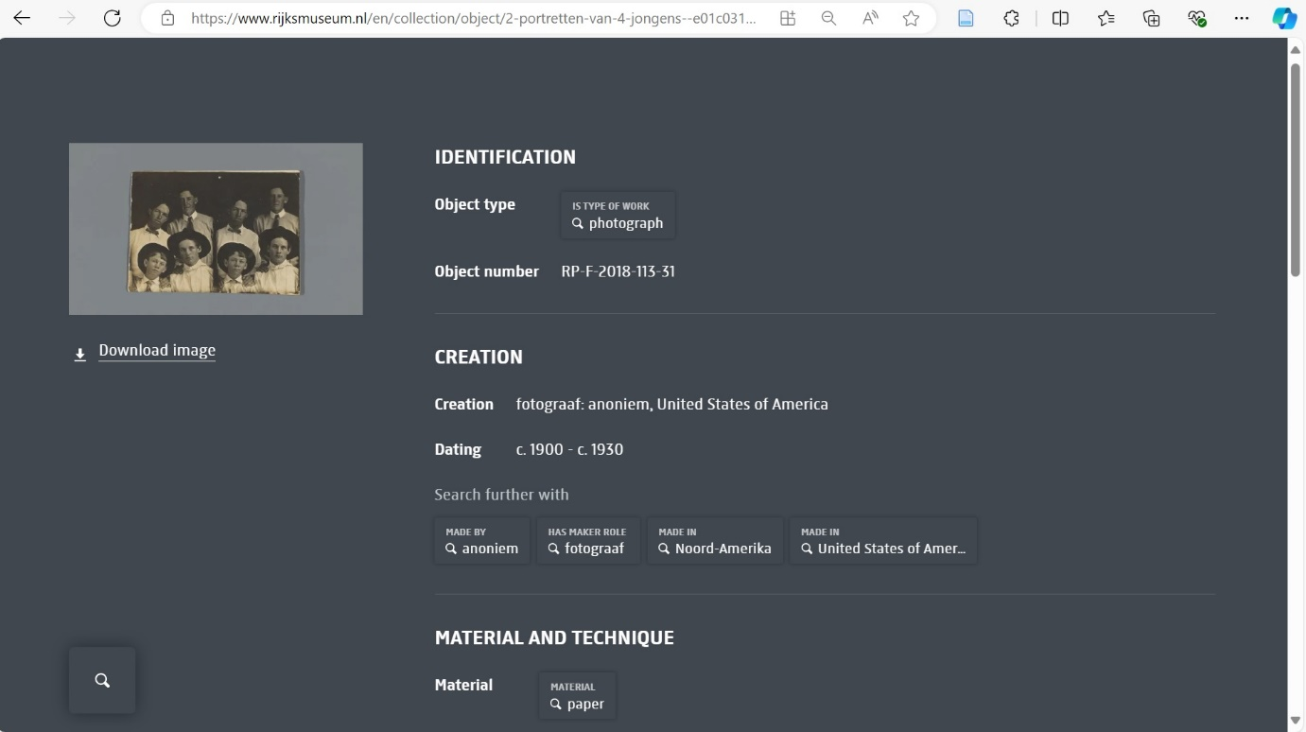
Image 24 – The Rijksmuseum Museum explorer, also allows users to ‘tell their story’ about a digital cultural heritage object.
There should be an improvement in providing access to digital heritage for computers, so called ‘Collections as Data’ and where possible providing Application Programming Interface (APIs) so computers can interrogate and grab thousands of items of digital heritage computationally.
I would suggest that GLAMs put their digital heritage in multiple places online where people are more likely to search so that they are more discoverable and not ignored on GLAM platforms.
One great idea is to create gifts that use digital cultural heritage from a GLAM and include a way to connect to the original item from that GLAM (where it came from) e.g. a website or QR code. Doing this will raise curiosity and interest of the people receiving their presents and offer a serendipitous way to further engage with the digital heritage from that GLAM.
It’s always a good idea to keep and show examples of use, reuse and remixing of digital cultural heritage to inspire others to come up with their own ideas.
Often creative and artistic uses of digital cultural heritage can communicate very clearly the value, benefit and interest of working with digital cultural heritage, so it is always a good idea to promote these examples heavily when trying to get more people engaged with digital cultural heritage.
Digital cultural heritage can counter fake news, especially when current news items refer to the past incorrectly, so as not to wipe out history and it can counter alternative false narratives.
Working with students to embrace digital cultural heritage creates sustainable approaches to working with digital cultural heritage for example a student project from Grade 8 in Estonia or with Masters Students on Digital Humanities courses. Working to embed digital collections into various courses requiring students to work with data through different ‘data’ projects works well in getting new uses of digital cultural heritage. Through these approaches it is possible to develop data literacy skills which have the potential to have wide appeal across the educational sector using digital cultural heritage.
Getting society to engage with cultural heritage would help build more educated and informed people, it would develop a curious mindset, it could help people understand themselves and each other better and create a better society.

