Better conditions for youth volunteering

The Position paper calls for continuing a solidarity-based program which
- funds youth volunteering
- focuses on solidarity
- strengthens civil society
- discovers new potentials
- is a value-based programme
- brings a new perspective for partner countries

It builds upon the Council Recommendation on mobility of young volunteers across the EU from 2022 and requests a stronger support and further development of volunteering schemes for young people in European Union and beyond.

The paper states the necessity to create new perspective for partner countries to be involved as stronger partners.

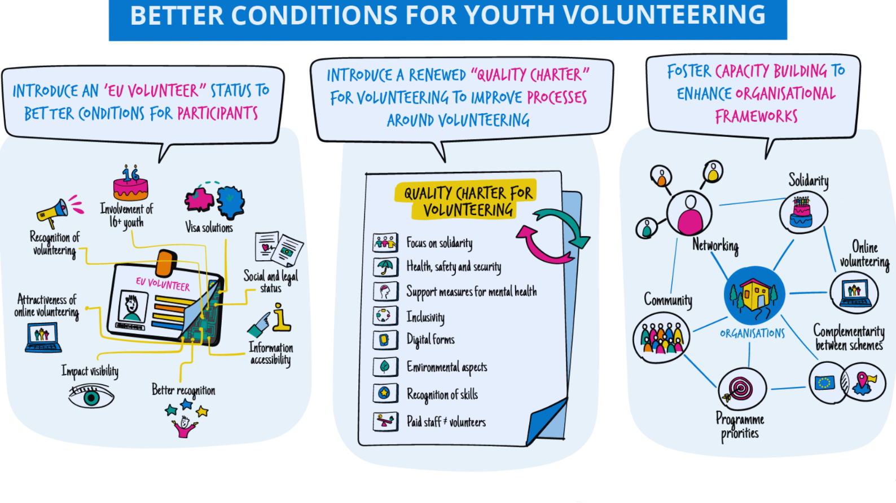
3 main areas of suggestions of the paper:

EU volunteer status

An EU volunteer status will bring more visibility and more clarity on the rights and responsibilities of the volunteers across Europe.

This status should bring:
- visa solutions
- clarification of social and legal status
- information availability and accessibility
- better recognition
- impact visibility
- attractiveness of online volunteering
- recognition of youth volunteering
- involvement of 16+ youth

A quality charter for volunteering
The quality charter should complement the Quality Label for organisations, and be a blueprint for high quality standards in the field of transnational volunteering.

While the Quality Label, as an essential part of the European Solidarity Corps programme, includes some practical guidelines on ensuring quality in the programme, a more holistic quality charter for volunteering in general provided by the European institutions is currently lacking.

A quality charter will include minimum standards and guidelines to:
- focus on solidarity
- ensure health, safety and security of participants
- include measures for mental health
- ensure inclusivity
- include digital forms
- include environmental aspects
- recognition of skills
- distinguishing between paid staff and volunteers
Fostering capacity building

Capacity building resources within the European Solidarity Corps (or successor programme) have the potential of systematically strengthening the cooperation in the civic engagement sector.

Ensuring that funding instruments including Erasmus+ KA2 and NET are available, being promoted and being used for capacity building in the field of solidarity and volunteering would help to:
- focus on solidarity
- foster networking and knowledge sharing
- explore complementarity between different volunteering schemes
- explore community involvement and impact
- increase thematic involvement and impact
- increase thematic work on/with programme priorities
- explore online volunteering

