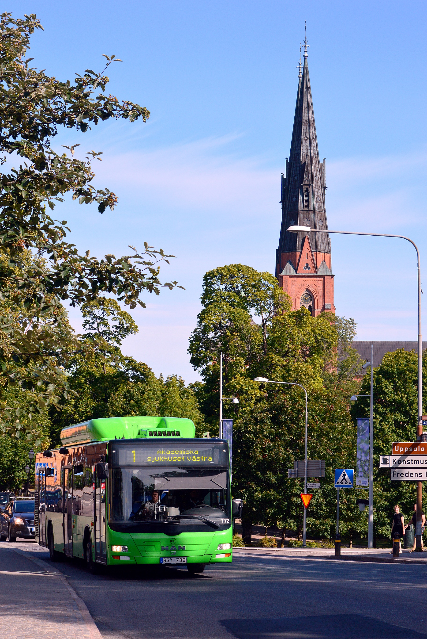

The City of Uppsala and
Uppsala County Council
welcomes
the Tartu County delegation
to Uppsala County
- 13-15 November 2023 -

Visitors program

Tartu County delegation
Participants:
Meelis Leidt: Deputy Mayor of the City of Tartu meelis.leidt@tartu.ee

Jarno Laur: Mayor of Tartu municipality and Chairman of Board at the Association of Municipalities of Tartu County , jarno.laur@tartuvald.ee

Priit Värv: Mayor of Elva municipality priit.varv@elva.ee

Annika Pajumaa-Murov: Mayor of Kastre municipality annika.pajumaa-murov@kastre.ee

Piibe Koemets: Mayor of Peipsiääre municipality piibe.koemets@peipsivald.ee

Maano Koemets: Mayor of Nõo municipality maano.koemets@nvv.ee

Illari Lään: Mayor of Kambja municipality illari.laan@kambja.ee

Aare Anderson: Mayor of Luunja municipality aare.anderson@luunja.ee

Sven Tobreluts: CEO, Association of Municipalities of Tartu County sven.tobreluts@tartumaa.ee

Kaidi Randpõld: Development manager, Association of Municipalities of Tartu County
kaidi.randpold@tartumaa.ee

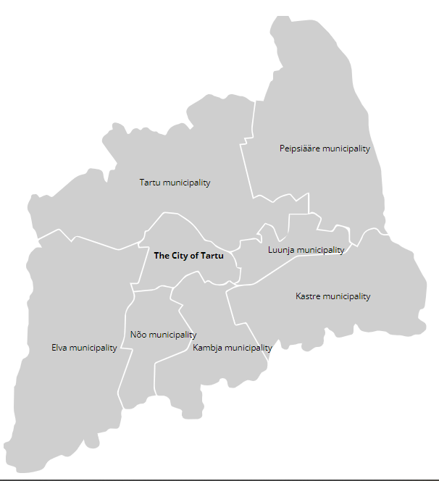
Home page – ENG (tartumaa.ee)
ACCOMMODATION
The Tartu delegation will be staying at Elite Hotel Academia, Suttungs gränd 6
Aim of the visit:
To intensify Estonian cooperation with Sweden, especially within the county of Uppsala.
Our regions are similar in size, structure and identified challenges. Tartu and Uppsala are twin-cities. We have also good cooperation between Tartu University and Uppsala University.
In particular, the current geopolitical and economic situation challenges us to establish new, closer cooperation in the Baltic Sea region.

Main themes of the visit:
Best practices from Uppsala County and City in the topics of:
- Sustainable school meals
- Circular economy
- Sustainable mobility
- Sustainable public transportation and cooperation between city and rural areas
- Liveable urban environment

Opportunity for discussion and mutual learning
Where discussion during the visit unearths common ground, opportunities for future initiatives will be investigated.

Program overview:

Monday 13 November
09:00 – 11:00 Welcome to the City of Uppsala
12:00 – 13:30 Lunch
13:30 – 17:00 Sustainable school meals

19:00 Dinner

Tuesday 14 November
08:30 Pick up from the Elite Hotel Academia
09:00 – 11:30 Sustainable foods
11:30 – 12:30 Lunch
13:30 – 16:00 Sustainable mobility

19:00 Dinner

Wednesday 15 November
08:30 Pick up from the Elite Hotel Academia
09:00 – 12:30 Liveable urban environment
13:00 – 14:00 Lunch
14:00 Departure

PROGRAM: Monday 13 November

9:00 – 11:00 Welcome to the City of Uppsala
Dag Hammarskjöld, Uppsala City Hall, Stadshusgatan 2
Erik Pelling (S), Mayor of City of Uppsala
Therez Almerfors (M), Deputy Mayor of City of Uppsala
Christian Dahlmann, Head of Unit for external affairs and management support, City of Uppsala
Sami Khalifeh, International coordinator, City of Uppsala
David Preuss, Climate policy advisor, Department for Sustainability, City of Uppsala
Elin Belleza, Innovation Leader, Uppsala Water and Waste LTB

The opening session will set the stage for the coming days together. The Tartu delegation will be welcomed to Uppsala by The Mayor and Deputy Mayor of the City of Uppsala. We will provide an overview of our organisation and mandate, the city’s operations, our current challenges, and our vision for the future.
We will also give a brief presentation of Uppsala - the circular city. Uppsala has long been one of Sweden’s fastest growing municipalities, and it has consistently maintained its reputation as one of Europe’s most sustainable mid-sized cities. But to put Uppsala on a 1.5-degree pathway, the pace of Uppsala’s climate transition will need to increase at least fivefold. This session will provide a general overview of Uppsala’s efforts to boost its circular economy, lifting both Uppsala’s wider strategic policy framework and examples of circularity in the building sector, waste collection processes, circular biogas production and distribution and local reuse initiatives.

The Tartu delegation is invited to give a short presentation of the Tartu region and provide questions and reflections after the presentations.

Coffee and refreshments will be served from 9:45
Uppsala City Hall
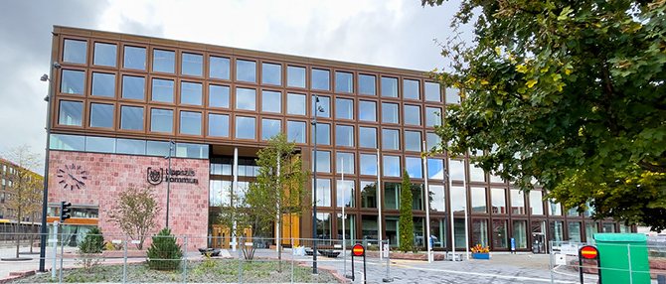
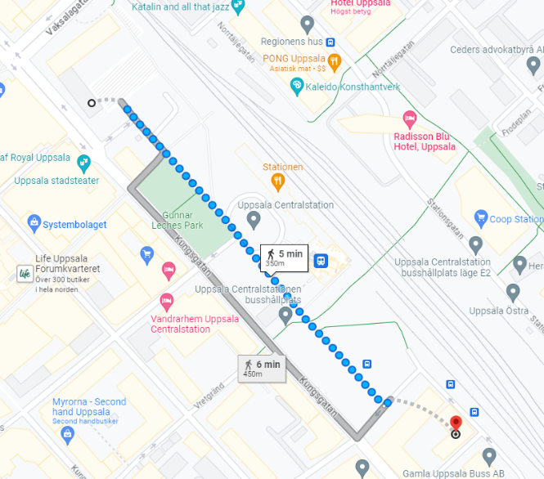
At 11:15 the Tartu delegation will be picked up from Uppsala City Hall and taken for lunch.
12:00 – 13:30 Visit to the school restaurant and kitchen including lunch
Lundellska skolan, Lägerhyddsvägen 36, 756 43 Uppsala
Anders Sundin, Head of department - Food services, City of Uppsala
Sara Nygård, Quality Manager/Dietician, City of Uppsala
Sandra Harbom, Development Manager, City of Uppsala
Theres Mortensen, Area Manager - Food services, City of Uppsala

The visit will start in the school restaurant and kitchen to show how the City of Uppsala works with managing flows of the 1.400 students eating every day. We will highlight buffé layouts, refilling of food, information of food waste and sustainable food etc.

Lunch will be served in the Lundellska skolan school restaurant.

13:30 – 17:00 Sustainable school meals
Lundellska School, Lägerhyddsvägen 36, 756 43 Uppsala
Anders Sundin, Head of department - Food services, City of Uppsala
Sara Nygård, Quality Manager/Dietician, City of Uppsala
Mattias Eriksson, Associate professor, Swedish university of agricultural science
Christopher Malefors, Researcher, Swedish university of agricultural science
Niina Sundin, Doctoral student, Swedish university of agricultural science
Amanda Sjölund, Doctoral student, Swedish university of agricultural science
Ingrid Strid, Researcher, Swedish university of agricultural science

The contemporary food system presents a significant challenge due to its lack of sustainability. Public catering organizations are pivotal in steering the shift towards a more sustainable food ecosystem, particularly in nations where school meal programs are widespread. Swedish public catering entities have taken proactive steps to mitigate the adverse effects of their food services. Their strategies primarily focus on minimizing food waste and transitioning menus to include fewer animal-based products, thereby aiming to reduce the environmental impact of their operations. Yet, achieving these goals isn’t instantaneous, requiring a sustained, long-term focus to ensure success.
This session will explore on-going initiatives, such as Uppsalas Lowinfood project https://lowinfood.eu/ and the Interreg Baltic Sea project “Farm-to-school“, and will provide the opportunity for discussion concerning possible future cooperation, and potential open calls for funds.

Keywords: Sustainable public catering, Food waste management.

At 17:15 the Tartu delegation will be picked up at Lundellska School, Lägerhyddsvägen 36, and dropped back at Elite Hotel Academia, Suttungs gränd 6.

19:00 Dinner - a table is reserved at the Rosendal Ost & Chark vinbar, Torgny Segerstedts Allé 93. The dinner will be hosted by Anton Derblom, an Uppsala food entrepreneur, in his soon to open wine bar.

At 18:40 the Tartu delegation will be picked up from Elite Hotel Academia, Suttungs gränd 6 and driven to the restaurant. The Tartu delegation will be returned to Elite Hotel Academia, leaving Rosendal Ost & Chark vinbar at 22:00.
We kindly ask the Tartu delegation, upon arrival at the restaurant, to confirm with the bus driver the desired pick up time.
PROGRAM: Tuesday 14 November
The Tartu delegation will be picked up at 8:30 from the Elite Hotel Academia

9:00 – 11:30 Sustainable food
Meeting up in front of Hospitalet Ulleråker, Ulleråkersvägen 34-42
Cyrille Gaubert, founder Uppsala Food council
Rebecca Waterhouse, project manager, Uppsala Food Council
Sara Rosen, Landscape architect, City of Uppsala
Daniel Lövgren, Researcher, Uppsala University
Elin Boström, Educationnal farmer
Rana Toprak, intern at Uppsala City
Sanaz Kalantari, intern at Uppsala City
Flynn Smedman, intern at Uppsala City

Each day the inhabitants of Uppsala need over 1,000,000 delicious, healthy and sustainably produced meals. To achieve and maintain this we need empowered long-term food strategies, collaboration among numerous stakeholders and functional organizational ecosystems, without any gaps. During this session, we will present the vision of Uppsala Food Council to achieve this goal and give an insight into the on-going project to develop an educational farm and a small-scale farming ecosystem in Uppsala. This project is one example of what the Food Council methodology aims to accomplish in Uppsala. We will explore and test this method with the delegation.

Keywords: Vision, collaboration, methodology, efficiency, impact

The Tartu delegation is invited to actively and interactively question our vision, choices, and methodology. We also invite you to participate in a brief workshop scheduled before lunch.

11:30 – 12:45 Lunch - will be served at 11.30, a short walk away, in a municipal project house close to the farm, Ulleråkersvägen 32.

At 13:00 the Tartu delegation will be picked up from Ulleråkersvägen 32.

13:30 – 16:00 Sustainable Mobility
Uppsala Bus depot at Fyrislund, Rapsgatan 35
Tommy Rydbeck, Technical Manager, Gamla Uppsala Buss
Evan Mitchell, Environmental Strategist, Uppsala County Council
Emma Hammarbäck, Development Strategist, Uppsala County Council
Madelene Håkansson, Mobility Strategist, Uppsala County Council

EUs agenda for energy reformation across Europe to address the climate crisis provides challenges and incentives for a necessary but complex transition in our regions. Within the transport sector this means addressing energy sources, infrastructure, and modality while at the same providing uncompromised accessibility, comfort, and safety for our residents and passengers. This session, based at the Uppsala bus depot, will combine a guided tour of our newly built facilities as well as case presentations of how we are meeting the challenges of a growing region by transitioning to renewable fuels, working with multilevel stakeholder collaboration, and promoting behaviour change.

Keywords: Public transport systems of the future, sustainable energy transitions, regional collaboration, multi-modal solutions, city-rural area cooperation

The Tartu delegation is invited to provide a brief overview of related public transportation challenges and solutions from the Tartu region for discussion.

Refreshments will be available from 14:15

At 16:15 the Tartu delegation will be picked up from the Uppsala Bus depot, Rapsgatan 35 and dropped at the Elite Hotel Academia

19:00 Dinner will be served at Walmstedtska gården, Sysslomansgatan 1
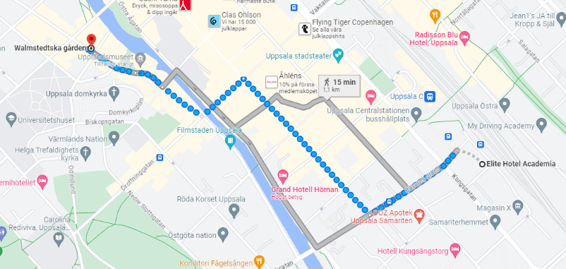
Walmstedtska gården lies a short walk from the hotel. The residential building and outhouse, built in 1855 for Prof. Lars P. Walmstedt, gives an insight into high-society living in Uppsala in the late 19th century. The property is currently owned by the municipality of Uppsala.
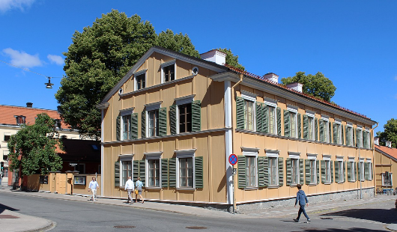
In attendance:
Klas-Herman Lundgren, Chair Uppsala City Council
Carl Lindberg, Deputy Chair Uppsala City Council
Magnus Åkerman, Deputy Chair Uppsala City Council
Christian Dahlmann, Head of Unit for external affairs and management support, City of Uppsala
Sami Khalifeh, International coordinator, City of Uppsala
Tobias Arvidsson, Director for regional development, Uppsala County Council
PROGRAM: Wednesday 15 November
The Tartu delegation will be picked up at 8:30 from the Elite Hotel Academia

9:00 – 12:00 Liveable urban environments
Torgny Segerstedts allé 52, Rosendal
Ronnie Nilsson, Landscape architect Rosendal, City of Uppsala

Rosendal has been woodland, a military training area and, more recently, a golf course, but today the area is a growing and vibrant Uppsala neighbourhood. Combining 6,000 apartments, parkland and sports arenas, public buildings and business facilities the area is now one of Sweden's most innovative residential areas. Since 2011 Rosendal has developed through combining new ideas, a modern city vision and broad innovative methods to tackle the challenges of sustainability. The final stage of construction will start in 2025, completion in 2029, as ambitions are raised further to make the district climate positive.

This session will provide insight into some of Rosendal’s key areas of sustainable innovation, both by presentation and guided tour. We will look more closely at functional, shared, and sustainable mobility services, the reuse and repurposing of materials, innovative stormwater management, wood as an alternative to concrete, solar cells and local energy production, and plant beds for carbon capture. We will show how, by prioritising cooperation in our planning process we have created broad-approach synergies to provide an inclusive streetscape in a green and climate positive urban environment.

Coffee and refreshments will be available at 10:15

At 12:15 the Tartu delegation will be picked up from Torgny Segerstedts allé 52

12:30 – 14:00 Lunch - a table is reserved at Uppsala Concert Hall & Conference Centre.
Since its inauguration in 2007, The Uppsala Concert Hall & Conference Centre has established itself as one of the Nordic countries' most talked about, appreciated and successful meeting places. It presents a cultural spectrum characterized by diversity, prevalence, and high quality. Since opening, the house has presented over 2,000 cultural events, arranged over 5,000 meetings and has welcomed over five million visitors.

14:00 - Departure

Contacts during your visit:

Primary contact:
Sami Khalifeh, International Coordinator, City of Uppsala
sami.khalifeh@uppsala.se +46 18 727 36 02

Andy Metcalfe, International liaison, Uppsala County Council
andrew.metcalfe@regionuppsala.se +46 18 617 01 41

Anders Sundin, Head of department - Food services, City of Uppsala
anders.sundin@uppsala.se

Cyrille Gaubert, Uppsala Food Council
uppsalamatrad@gmail.com

Evan Mitchell, Environmental Strategist, Uppsala County Council
Evan.mitchell@regionuppsala.se

Ronnie Nilsson, Landscape architect Rosendal, City of Uppsala
ronnie.nilsson@uppsala.se

Welcome to Uppsala!
We look forward to meeting you
and to shared insightful and fruitful discussions.

Erik Pelling Unn Harsem Tobias Arvidsson
Mayor of City of Uppsala Chair of Regional development Board Director of Regional development
City of Uppsala Uppsala County Council Uppsala County Council

