EEG Expert
Instructions for Symptom Tracking “Remote-User”

Prerequisites:
- General client data must have been entered (gender, DOB, abbreviation, etc.)
- Setup of Symptom Tracking must be completed (selection symptoms to be tracked)
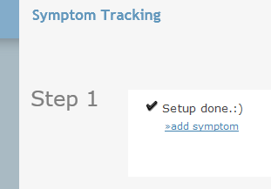
- Go to Sytmpom Tracking of client selected, then click on Remote-User
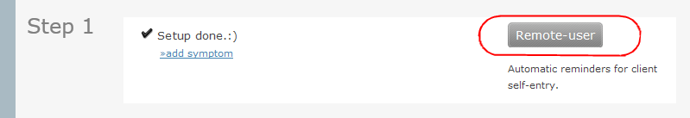

Setting up Remote User Step-by-Step
- This is the screen you see:
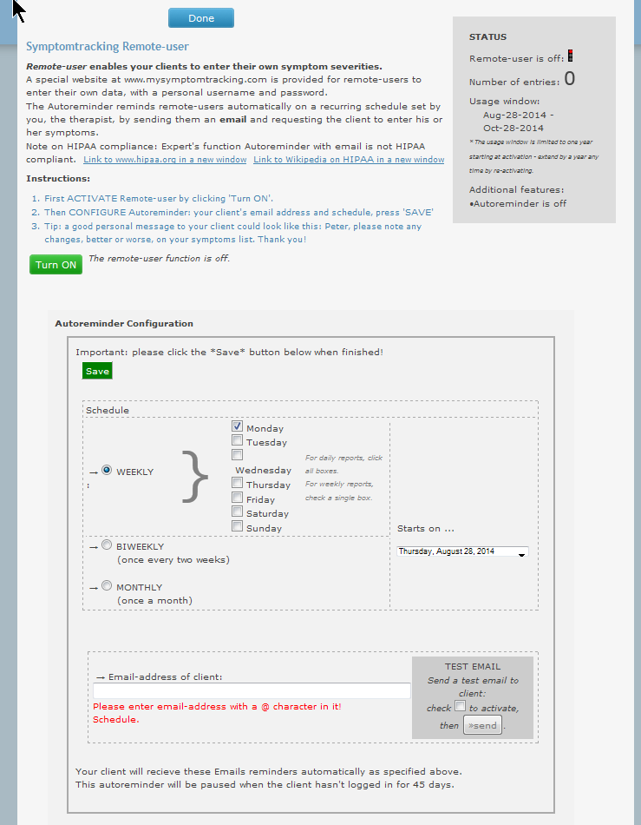
- Turn on Remote-User function:
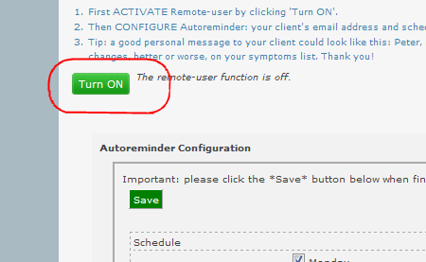
The button will switch to:
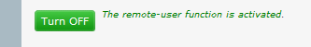
In the future, use this button to turn off Remote-User if necessary
- Set an automatic schedule for the Email reminders to your client:
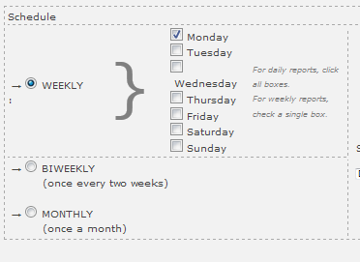
Select weekly for a weekly schedule, biweekly for once every two weeks and monthly for monthly. In weekly, you can select on or more days for the reminders to be sent.
- Select a starting date, or leave the field as is if you want to start immediately:
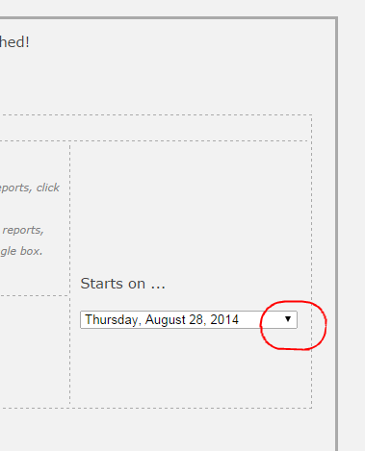
- Enter your client’s Email address:
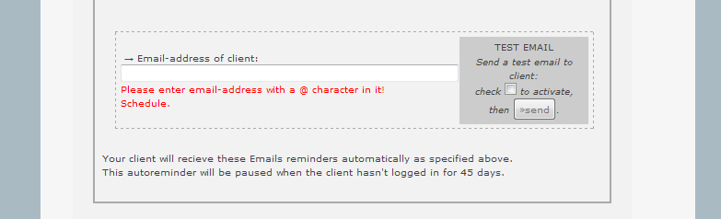
You can send a test Email to check if your client receives the Emails from service@mysymptomtracking.com. Use the gray section on the right for that. Before testing Email, remember to save your entries.
Emails sent to the client may be caught in your client’s spam folder. Please have your client check if there are difficulties.
- Optionally, enter a message to your client which will be included in every automatically sent reminder Email:
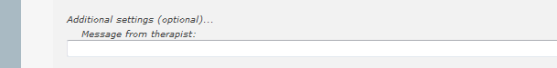
- Save when you are done with the entries:
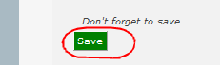
- In each reminder Email, your client will receive login information to access the website www.mysmptomtracking.com . He or she can then enter the severities of the symptoms the therapist selected during setup.
- Your client’s login information is displayed in the next section:
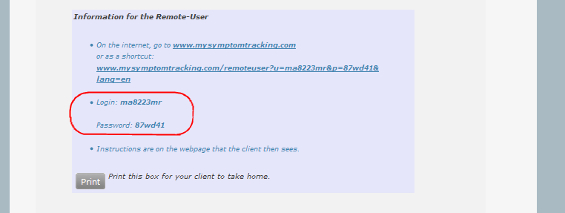
Above the red box is a long link with the login information. This is the link that get’s sent to the client. All they have to do is click on it.
- A usage window is automatically set so that accounts don’t go on forever.
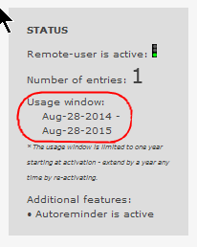
If you need to extend the usage, just switch off and then on again – the usage period will automatically extend.
- Remote-User function may also be called Autoreminder.
- You can always review the entries done using
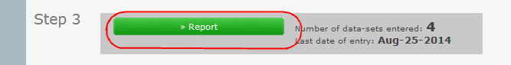
on the original Symptom Tracking page for the client.
- On the report chart, who entered the data is indicated:
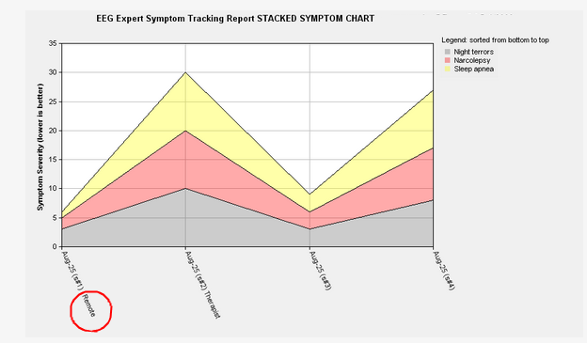
- Detailed information on the tracking is presented at the end of the report.
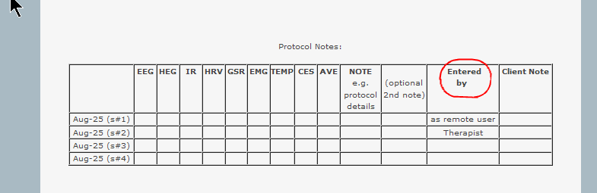
- You can always save or print the report using the PDF button at the top of the page

- If your client doesn’t login for 45 days or more Symptom Tracking get’s turned off for that client.

