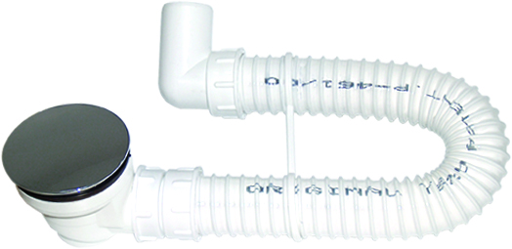
Product code: S00097M

Flexible bath siphon Ø90- LUX 90

For installation in all types of showes tubs with the 60mm diameter opening.In addition to contemporary designed cover waste collection vessel integrated in the inlet connection, enables easy, fast and efficient cleaning.

Basic components of flexible siphon are:
- Flexible PVC pipe diameter 40mm, with smooth interior and spiral wound corrugated exterior.

- Inlet connection with chrome olated cover and waste cleaning vessel.

- Adapter for inlet connection with 5/4“ thread and sealing washer.

- Adapter diameter 40mm for sewer pipe 50mm or adapter diameter 29/32mm for lead drain pipe 5/4“.

EAN number: 8716236433520

Packing: A02002, BOX dimension 800x400x360mm

Wrapping: Polyethylene bags, NO PRINTED

Quantity per box: 25

Quantity per palette: 450
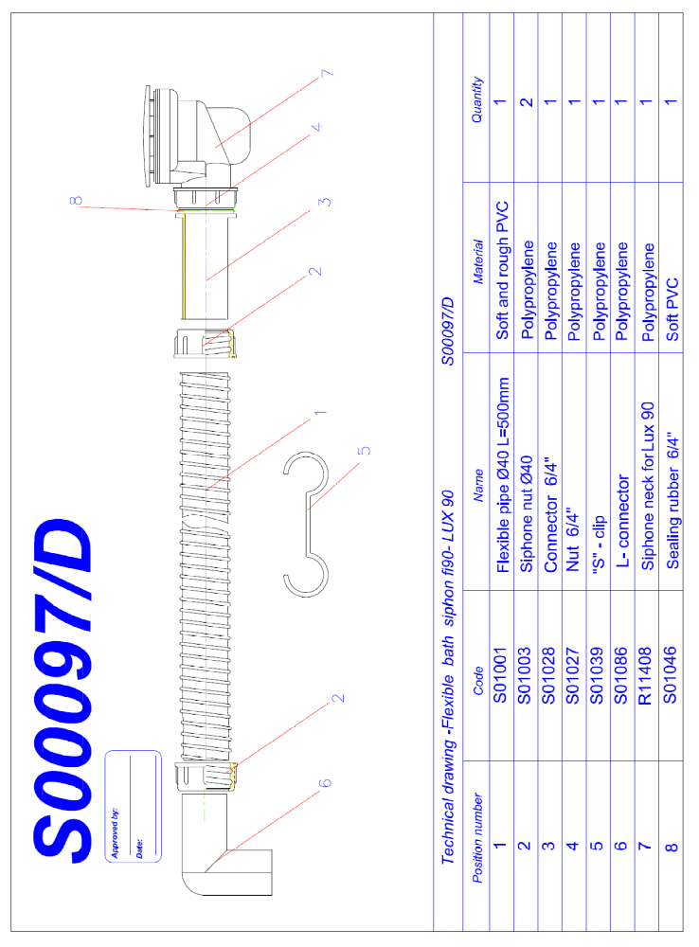
Individual Packaging:

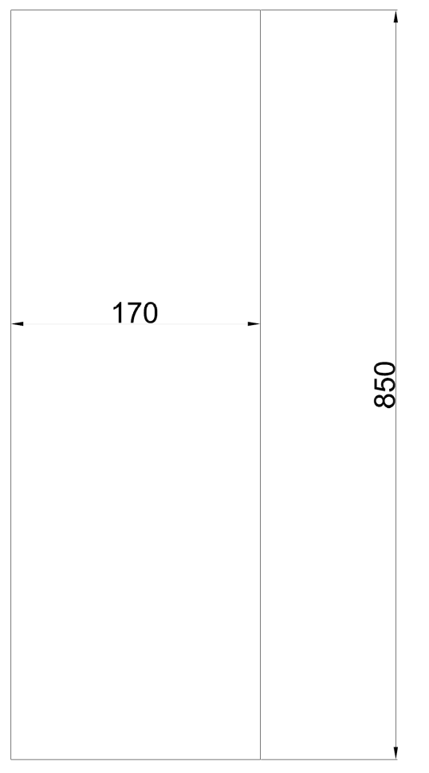

Packaging: Box code: A02002

Each box on 1 palette and in left top corner labeled with
One label containing: See Label below
Tape on boxes must have equal length on both sides.
ISPM Euro palettes: 1200 x 800 mm.

Stacking: A02002

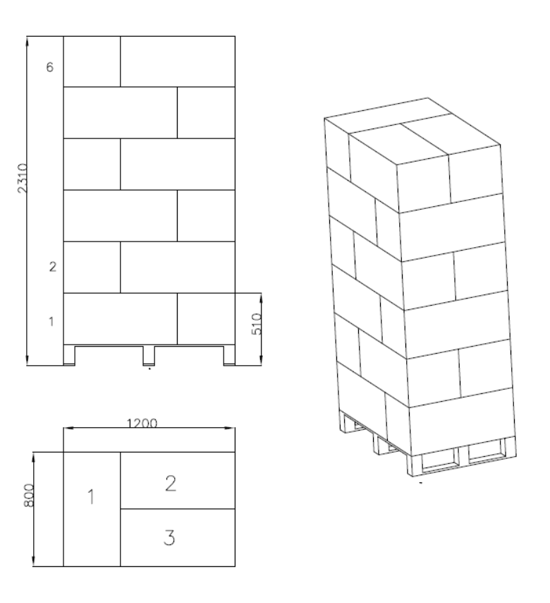
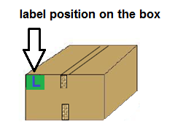
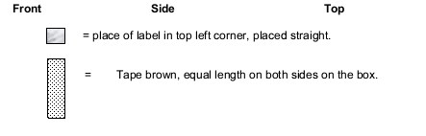

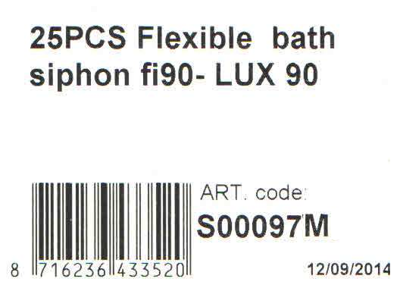

Related documents: S00097M

Approved by Tehnoexport
Date:08 Septembar 2014

Name: Aleksandar Cabrilo


