Specification and Inventory

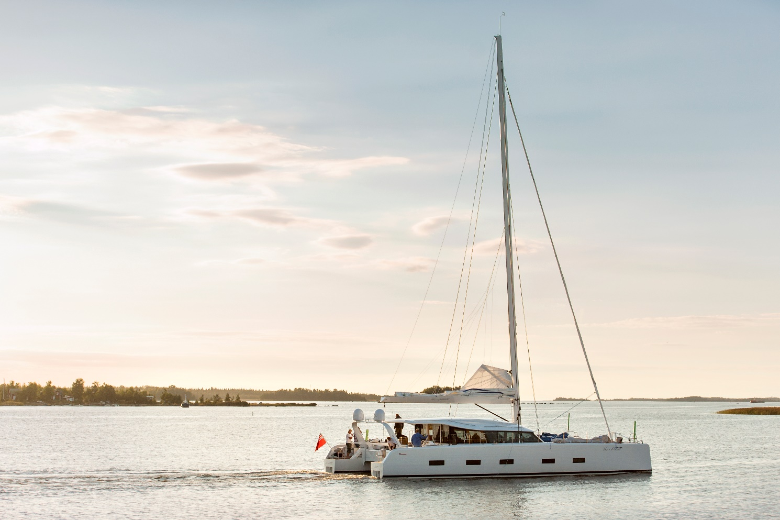

CONSTRUCTION

RCD Status:
- The vessel comply with the European Union Recreational Craft Directive and is Categorised CE- Ocean A (DNV-GL)

Hull Construction:
- Sandwich construction, E-glass reinforced with carbon, vacuum infused with epoxy in female moulds.
- Bulkheads and stingers in carbon fibre, vacuum infused.
- Daggerboard cassettes in carbon
- Shroud chain plates in carbon fibre, integrated into the hull
- Each hull is divided into 3 watertight sections
- Crashbox in bows for collision protection
- Hull spray painted in August 2020 with Awlcraft 2000 Pure White OF8014
- Boot stripes on hull is painted August 2020 with Awlcraft 200 Aristo Blue OF5010
- Hull draft 0.90m

Deck & Superstructure Construction:
- Main deck, Epoxy + e-glass, Carbon reinforced, vacuum infused
- Deckhouse structure in titanium
- Deckhouse roof, Epoxy + E-glass, Carbon reinforced, vacuum infused
- Deck spray painted in August 2020 with a 50/50 mix of Awlgrip Matterhorn White Semi Gloss Reaction Lacquer and Awlgrip Snow White Semi Gloss Reaction Lacquer
- Teak laid cockpit sole
- Forward crossbeam, Carbon infused with integrated trampoline net track
- Longeron, Carbon infused, integrated anchor system and trampoline net track
- Windows, laminated/ tempered glass. Grey STL-42 film between the layers.

Daggerboards & Rudders:
- Curved carbon fibre retractable daggerboards for improved performance
- Daggerboard lifting system, electrical with indicators and backup system
- Retractable rudders made in carbon fibre with stainless steel shafts
- Rudder draft 1.6m when down
- Position monitoring on the daggerboards

MACHINERY

Engines & gearboxes:
- 2 x Steyr MO114K33 Diesel (110 hp)
- Engines located midships, accessed from inside hulls
- Shaft drive with Brunton varifold propeller
- Well insulated engine rooms
- The yacht is equipped with forced supply and exhaust ventilation.
- 1 x Steyr 24vdc Flywheel generator on port side engine

Service & Maintenance:
- Engine hours – approx. xxxx Hours as of August 2020
- Date of last engine service – Delivered new serviced

Propulsion & Steering:
- VIP 150 Max Power hydraulic retractable bow thruster. New refitted August 2020
- Hydraulic steering from port and starboard side with backup systems
- Rexroth handheld remote to control engines, thruster and windlass with.

ELECTRIAL SYSTEMS

Voltage systems:
- 24vDC domestic system with 12vDC engine start bank and 220vAC system via shorepower, generator or inverter
- The electrical system is grounded to the water by grounding plates, one in each hull

Battery Banks:
- 6x 200AH Mastervolt Li-ion 24vDC service batteries joined to supply 1,200Ah @ 24vDC
- 2x 80Ah 12vDC engine start batteries

Battery Charger:
- 2x Mastervolt 100Amp automatic battery chargers

Inverter:
- Mastervolt MASS Sine 24/5000 5kw 220vAC inverter

Alternators:
- 12vDC engine alternator

Generator:
- New Fisher Panda 15000i PMS 15kw 220vAC diesel generator
- Generator hours – refitted August 2020
- Date of last generator service – New generator

Solar:
- 18sqm of sunbeam solar panels with charge regulator

Shorepower:
- Shorepower 230 V 50- 60 hz
- Mastervolt GI7 isolation transformer with main fuse and earth fault switch
- 3 x AC Bus, controlled from PLC system
- 220vAC sockets throughout interior

Digital Switching:
- Empirbus digital switching system monitoring and controlling Sailing functions, Windlass & yacht controls, Daggerboards, Lights, Steering Console, Bilge system, Tank levels, Freshwater system, Black water system, Fuel system, Ventilation, Generator and Appliances

Burglar alarm
- Burglar alarm on the boat with remote control settings. Fire sirens on the boat will sound if alarm activated.

PLUMBING & GAS SYSTEMS

Fresh Water:
- Fresh water pressurised by 24vDC centrifugal pressure pumps with 24 litre accumulator tank
- Hot water supplied by engine driven calorifier in 2x 50 litres hot water tanks with 1.2kw 220vAC immersion heater elements
- Hans Grohe shower and heads for fresh water supply in galley and heads
- Deckshower in locker at mast area and at aft end.
- Deck/Chain water in forward starboard locker

Watermaker:
- Schenker Modular 150 reverse-osmosis watermaker producing 150 litres per hour

Bilge Pumps:
- Each hull is divided into 3 separate flooding sections, each section with own Rule 24vDC bilge pumps.
- Main bilge pump: Johnson F38 – 19 (Impeller pump)
- Generator room, bilge pump - Whale Gulper 320 (membrane)
- All bilge pumps have external sensors.

Black & Grey Water Systems:
- Sewage treatment system for both black and grey water
- 200 L blackwater/greywater tank
- Grey water from galley runs straight out via its seacock located in the port aft bathroom.

Skin Fittings:
- Through hull fittings and seacocks in engine spaces AISI 316 stainless steel, seawater resistant brass
- Hull through fittings of composite.

TANKAGE

Fuel:
- 1450 litres of fuel capacity in 4x tanks with transfer between tanks using electrical pump

Fresh Water:
- 900 litres of freshwater capacity in 2x tanks with transfer between hulls with a electrical pump

Holding Tanks:
- 215 litre blackwater holding tanks discharging overboard through a sewage treatment system (US coastguard approved) or via deck extraction points

NAVIGATION & COMMUNICATION EQUIPMENT

In Cockpit:
- B&G Zeus 3 chart plotter x 2
- B&G H3000 Autopilot
- B&G H5000 graphic display x 2
- B&G H3000 10/10 display x 8
- GNSS satellite compass
- B&G 4G Radar
- Depth sensors

At Chart Table:
- B&G Zeus Chart plotter
- B&G H3000 GFD mono display x 2
- B&G 30/30 display x 3
- H3000 CPU
- B&G NAIS – 400 AIS
- Forward looking eco sounder

Communications Equipment:
- Fleet ONE satellite telephone
- Glomex Webboat 4G and shore wifi
- B&G V90 Vhf

DOMESTIC EQUIPMENT

Galley:
- Gas stove with oven
- Witt 60GL galley extractor fan
- Siemens SL6P1S dishwasher
- Isotherm DR 190 & Isotherm CR85 fridges
- Frigonautica C130C freezer
- Isotherm 4106K icemaker
- Galley Exhaust fan, Witt 60GL

Laundry:
- Aquamatic Aqua 220vAC washer/dryer

Heads:
- 4x Tecma 24vDC electric freshwater flush heads
- 4x showers with hot & cold pressurised supply

Heating & Ventilation:
- Frigomar 220vAC reverse-cycle air-conditioning system with 42,000BTU 607NT chiller and 728 handlers in accommodation cabins and 751 handler in saloon.
- Additional ventilation provided via hatches and doors.

Entertainment:
- Fusion Stereo System with speakers in cabins
- Wi-fi system with router
- Hidden LCD TV in saloon

ACCOMMODATION

Summary of Accommodation:
- The contemporary styling of Like a Breeze, with clean lines and sleek deckhouse design, allow for panoramic views without compromising on the look of the yacht.
- The interior layout of Like a Breeze is second to none, with the ingenious use of space to optimise the functionality, while retaining the elegance and spacious feel.
- Her three guest cabins are all ensuite, with queen sized double beds in the aft living quarters.
- Additional ensuite crew/guest bunk cabin in the forward hull.

Accommodation Finish:
- Canadian Ash veneers throughout
- Doors are of Canadian Ash glued over Divinycell cores
- Exposed hull sides and headlinings finished in synthetic suede
- Floors in teak with constrasting black caulk inlays
- White Corian countertops
- Cream cloth upholstery
- Downlight LED’s throughout
- Hull window blinds

Accommodation layout from Forward:

Forward Cabin starboard:
- Queen size bed
- Storage cabinets
- Sofa with storage space located outboard
- Laptop table
- 2 x large side hull windows
- Full bathroom with separate shower

Forward Cabin Port (Serving as optional crew cabin):
- 2 Single bunk beds
- Storage under bed in cabinets
- Large hull windows
- Full bathroom with included shower

Aft Cabins Starboard & port side:
- Queen size double bed, longitudinal positioned
- Storage in cabinets and under the bed
- Laptop table
- 2 x large hull side windows

Aft Cabins Starboard & port side heads:
- Full bathroom with separate shower

Saloon
- The navigation station is located on port forward side.
- The Kitchen island includes a large 190 DR Inox fridge.
- Ample of storage space is found under the L-sofa
- The kitchen includes a gas stove and oven.

DECK EQUIPMENT

Rig:
- Lorima white painted carbon fibre mast
- Air-draft 26.77m
- Lorima white painted V-profile Carbonfiber boom
- Hydraulic vang with quick release
- Shroud chain plates in carbon, integrated into the hull
- Lazyjacks for mainsail
- Harken hydraulic traveller for mainsheet.
- Hydraulic forestay tensioner
- Reckmann hydraulic jib furler

- Harken electric staysail/storm jib furler
- Self-tacking track for jib
- Spinlock jammers
- I = 22.105m
- J = 6.6m
- P = 21.6m
- E = 8.2m
- ISP = 24.7m

Winches:
- 6x Harken 70.2 STEA electric 2-speed self-tailing winches for sheets, halyard and mainsheet
- 2x Harken 46 ST manual 2-speed self-tailing secondary winches

Sails:
- North Sails 122sqm full-battened 3DI offshore mainsail (Brand new waiting to be delivered)
- North Sails 64sqm furling triradial jib
- North Sails 35sqm storm jib
- North Sails 190sqm furling 3DI Code Zero (Brand new waiting to be delivered)
- North Sails 263sqm A4 furling Gennaker
- Parasail 340sqm

General:
- Stainless steel pulpits, pushpits and guardwire stanchions
- Side boarding gates
- Bow seats set into pulpits
- Carbon fibre passarelle
- Helmsman removable chair with backrest
- 2x GRP cockpit tables
- Extendable cockpit tables
- Stainless steel bathing ladders
- Custom made composite electric davits

Anchoring & Mooring:
- Maxwell HRC10-10 24vDC electric windlass with remote control
- Anchor and chain
- Complete set of anchors, fenders and mooring lines

Covers, Cushions & Canvas:
- Bimini top over helm positions
- Aft cockpit shade with track
- Aft cockpit tent
- Cockpit cushions

Tender & Outboard:
- Southern pacific inflatables, model cormorant 430. New January 2020 and 4 stroke 50hp Honda outboard -2013

SAFTEY EQUIPMENT:

General note on safety equipment: Any safety equipment such as liferafts, Epirbs, fire extinguishers and flares etc. are usually personal to the current owner(s) and if being left on-board as part of the sale of a used vessel may require routine servicing, replacement, or changing to meet a new owners specific needs.

- Cannister liferafts at each transom
- 4 x 2kg fire extinguisher located in sleeping cabins
- 6 kg fire extinguisher located in deckhouse

