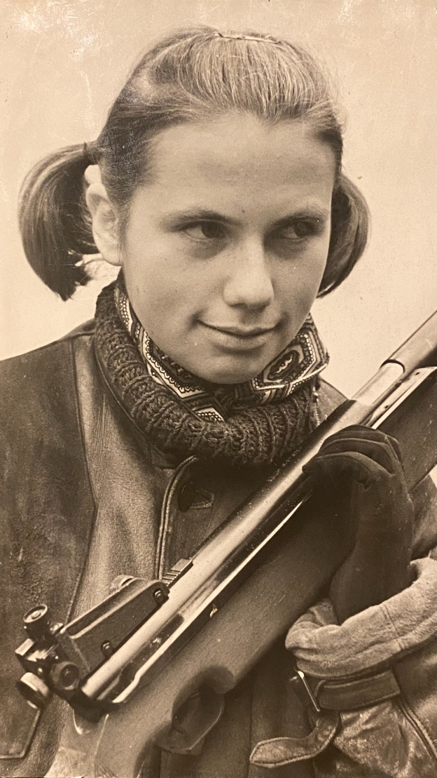

INVITATION
Dear shooters,
Elva Shooting Sport Club and competition organizing committee invites you to the international shooting competition - 50th Heli Rass memorial competition from 29th April to 1st May 2022 in the Elva Shooting Sport Centre!
Please see the competition general info and schedule below.
Lennart Saarepuu
Chairman of the organizing committee

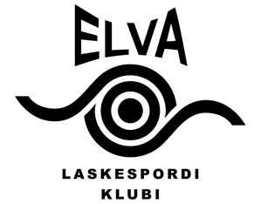
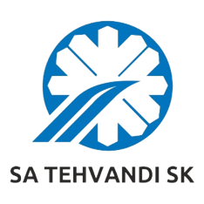

50th international Heli Rass memorial

Tartumaa Tervisespordikeskus, Elva

29th April – 01st May 2022

GENERAL INFORMATION
Schedule:
Friday, 29. April
13.00 25 m military rapid fire pistol 3x20 shots M, W
15.00 50 m pistol 60 shots M, MJ (Sius)
50 m rifle prone with stand 20 shots for youth shooters, 12-14 years MJ, WJ (Sius, final range)

Saturday, 30. April
8.30 Opening ceremony
9.00 25 m standard pistol 20+20+20 shots M, MJ, W, WJ
10.00 50 m rifle prone 60 shots W, WJ (Sius, final range)
50 m rifle 3x40 shots M, MJ (Sius)
50 m running target 30+30 shots M, W
12.00 25 m rapid fire 30+30 shots M, MJ
14.30 50 m rifle prone with stand 20 shots for youth shooters, 12-14 years MJ, WJ (Sius, final range)
17.00 50 m rifle 3x40 final M, MJ (Sius, final range)
18.00 25 m rapid fire final M, MJ
20.00 Awarding ceremony, bonfire, evening program

Sunday, 01 May
9.00. 25 m pistol 30+30 shots W, WJ, MJ
25 m centre fire pistol 30+30 shots M
50 m rifle prone 60 shots M, MJ (Sius, final range)
50 m running target 20+20 shots mix. M, W
50 m rifle 3x40 shots W, WJ (Sius)
16.00 25 m pistol final W, WJ
50 m rifle 3x40 final W, WJ (Sius, final range)
17.30 Awarding ceremony

Starting times indicates the first competition shot, shooters are called to the line 20 minutes before.
Finals times may change during the competition.
Organizers have the right to change or cancel the competition due to Covid-19 spread and regulations.

Results:
Records shall be kept separately for women, men, junior female and junior male (born 29 April 2001 and later) age classes. Finals will be held in Olympic disciplines for 8 best from absolute ranking. In case some of the finalists cannot participate in final, next shooter from absolute qualification ranking will be called.

Awards:
Three best from each exercise in adult and junior age categories will be awarded with a medal and diploma. Three best of the finals will be awarded with special prizes.

The nomadic trophies statute:
With the nomadic trophy “The best women rifle shooter”, issued by the Heli Rass´s parents, will be granted to the best female rifle shooter who obtains the best summary of two fire rifle scores (without finals).

With the nomadic trophy “The best result”, issued by the Tartu District Physical culture and Sports Committee in 1973, will be granted to the shooter who obtains the best result in the competition according to the official class standards.

Management:
All travel, entry fees and accommodation expenses shall be borne by the participants.

Entry fees:
15 € per shooter per start (adults and juniors)
5 € per youth shooter in 20 shots prone with stand

Preliminary Entries:
No later than 18th of April 2022 by e-mail: elvalask@gmail.com
Please use the entry form given by the organizers.

Information:
Karl Kontor +372 505 4006
Lennart Saarepuu +372 5361 0785
Maarja-Liisa Maasik +372 5330 6706
www.elvalask.ee or elvalask@gmail.com

Accommodation:
tel. +372 745 6333 or +372 555 12492
www.tervisesport.ee

Organizers: Elva Shooting Sport Club and SA Tehvandi Sports Centre

