
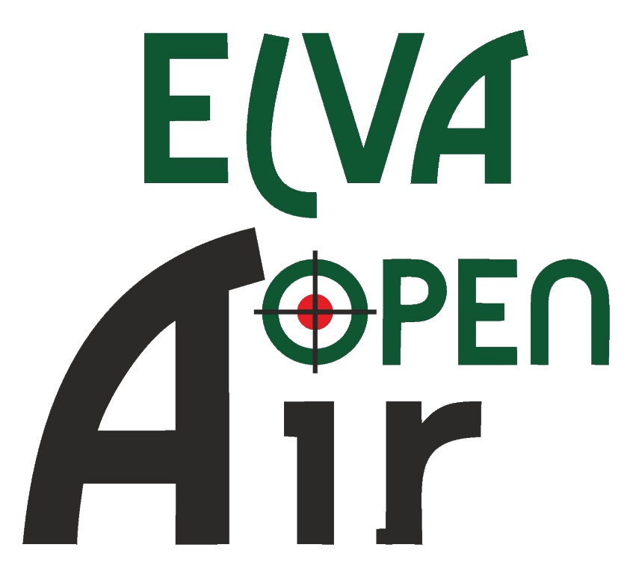




Invitation

Dear shooters,

Elva Shooting Sport Club and the Organizing Committee are glad to invite all shooters and team leaders to the international shooting competition „Elva Open Air 2026“.

Competition will take place at Elva Sport Hall, address Tartu mnt 3/1, Elva, Tartu County, Estonia from 12th to 15th of February 2026.

We want to offer you the opportunity to popularize and develop shooting sports and prepare for the European Championship in Yerevan February-March 2026.

Board of the Elva Shooting Sports Club

Lennart Saarepuu

Maarja-Liisa Maasik

Marianne Tavits

Reijo Virolainen

Karl Kontor

General information

Shooting events and categories:

10 m Air Rifle 60 shots W; JW; M; JM + Super final (8 overall best results)
10 m Air Pistol 60 shots W; JW; M; JM + Super final (8 overall best results)
10 m Mix Team Rifle JW-JM; W-M + MM
10 m Mix Team Pistol JW-JM; W-M + MM

Schedule:

Thursday 12.02.2026.
Arrival of Delegations
14:00 - 19:00 Equipment control
15:00 - 20:00 Unofficial training
19:30 Technical Meeting

Friday 13.02.2026.
8:00 - 18:00 Equipment control
09:00 - 15:00 Air Rifle and Air Pistol Mix Team Qualification round
16:30 - 19:00 Mix Team finals (Bronze and Gold medal matches)
19:00 Award ceremony

Saturday 14.02.2026
7:00 - 21:15 Equipment control
8:00 - 21:15 Air Rifle and Air Pistol 60 shots 1. start maximum 7 relays

Sunday 15.02.2025
7:00 - 17:30 Equipment control
8:00 - 16:15 Air Rifle and Air Pistol 60 shots 2. start 5 relays
18:00 Super finals for Air Rifle and Air Pistol
20:15 Award ceremony
Departure

The latest Schedule updates will be provided at the Technical Meeting.

Rules and regulations:

Elva Open Air qualifications and finals will be conducted according to the ISSF Rules.

Super finals are held on Sunday evening and will have top 8 shooters competing from the absolute standings, where goes the result of second start.

Each country can register as many mixed teams as wanted. Mixed teams can consist of athletes from two different countries. If you have an athlete, who would like to shoot a mixed team event, but do not have another team member, then you can register competitor as “lottery mixed team participant” and organizers will try to find this athlete a partner.

Individual participants: maximum 280
Mix teams: maximum 60 (air rifle) and 60 (air pistol)

The organizers reserve the right to make changes to the program and rules if necessary.

Rifle / Pistol Equipment:

Equipment Control will be conducted according to ISSF Rules using approved,
calibrated instruments.
Pre-competition equipment control is not mandatory however, athletes are responsible for competing with legal equipment and clothing. All athletes are urged to submit any doubtful equipment and clothing to Equipment Control for checking before the competition. All athletes are subject to being selected for random post-competition testing and will be disqualified if their equipment or clothing is not legal according to ISSF Rules.

ENTRY PROCESS AND FEES:

Please complete the attached Registration Form and return it by e-mail: elvalask@gmail.com no later than 22th of January 2026.

Entry fee:
30€ per individual start
30€ per mix team start
Entry fees must be paid by bank transfer to the Elva Shooting Sport Club
(SWIFT Code HABAEE2X; IBAN EE282200001120119799)
Cash payment is also an available option to pay before the event start.
Invoice for payment can be obtained from the secretariat.

SHOOTING RANGES AND VENUES:

Competition will be held in Elva Sport Hall. The venue is 20-minute drive distance from Tartu city centre, 210 km from Tallinn Airport and 225 km from Riga Airport.
Elva Sport Hall address: Tartu mnt 3/1, Elva, Tartu County, Estonia.
Air rifle and air pistol disciplines will be held in a 10 m range. There will be 40 firing points that are all equipped with SIUS electronic targets. Finals will take place at the same location.
More info: https://elvasport.ee/spordiobjektid/elva-spordihoone/.
Catering is organized in Elva catering establishments, which are located within a radius of 300 m from the Sport Hall.
Weapons, ammunition, and equipment storage room will be located within the Sport Hall.

ACCOMMODATION:

To book accommodation, please contact the hotels in Elva, Otepää and Tartu.
The nearest accommodations are:
- Tartumaa Tervisespordikeskus, 3 km +372 55512472 tartumaa@tehvandi.ee
- Verevi Motel 1 km https://uus.verevi.ee/et
- Waide Motel 5 km https://waide.ee/
- Kääriku Sport Centre 35 km https://kaariku.ee/
- Tehvandi Sport Centre 25 km https://www.tehvandi.ee/
- Tartu hotels 25 km https://visittartu.com/et/majutus

CEREMONIES and awarding:

The award ceremonies will take place after finals at Sport Hall.

The top three based on 1st individual competition start results will be awarded with medals. All weapon types and age groups (women, men, junior women and junior men) will be awarded.
Superfinals podium places will get trophies and first place wins a big special prize! All participants of the air rifle and air pistol super finals will be awarded with sponsors' prizes.

There will also be some special prizes from our sponsors and supporters!

MEDIA RELATIONS:

The contact person for media facilities is Ms. Maarja-Liisa Maasik
e-mail: elvalask@gmail.com

CONTACTS:
ORGANIZING COMMITTEE
E-mail: elvalask@gmail.com
Competition info: www.elvalask.ee/elvaopenair

