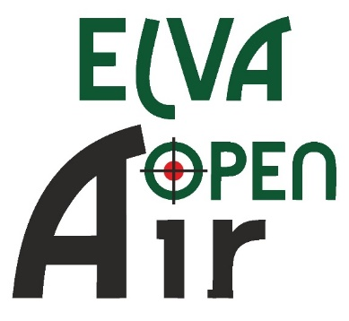

SCHEDULE

THURSDAY 12.01.
Arrival of Delegations

14.00 – 18.00
Equipment Control

15.00 – 18.00
Unofficial Training

18.30
Technical Meeting

FRIDAY 13.01.

08.00 – 19.00
Equipment Control

09.00 – 10.15
10m Air Pistol / Air rifle 60 shots I relay

11.00 – 12.15
10m Air Pistol / Air rifle 60 shots II relay

13.00 – 14.15
10m Air Pistol /Air rifle 60 shots III relay

Finals

15.00 – 15.45
AP MJ / AR MJ + AC

16.15 - 17.00
AP WJ / AR WJ + AC

17.30. - 18.15
AP M / AR M + AC

18.45 - 19.30
AP W / AR W + AC

20.00 -22.00 Banquet for representatives and coaches

SATURDAY 14.01.

08.00 – 19.00
Equipment Control

09.00 – 10.15
10m Air Pistol/Air rifle 60 shots I relay

11.00 – 12.15
10m Air Pistol/Air rifle 60 shots II relay

13.00 – 14.15
10m Air Pistol /Air rifle 60 shots III relay

15.00 – 16.15
10m Air Pistol /Air rifle 60 shots IV relay

SUPERFINALS

18.00 – 18.20 Ranking Match 10m Air Pistol

18.25 – 18.45
Gold Medal Match Air Pistol

19.15 – 19.35
Ranking Match 10m Air Rifle

19.40 – 20.00
Gold Medal Match Air Rifle

20.15 Award Ceremony

SUNDAY 15.01.

8.00 - 13:00
Equipment Control

09.00 – 09.30
10m Air Rifle/Air Pistol Mixed Team I relay

10.15 – 10.45
10m Air Rifle/Air Pistol Mixed Team II relay

Finals

12.00 – 12.20
Bronze Medal Matches 10m Air Pistol Mixed Team

12.30 – 12.50
Gold Medal Match 10m Air Pistol Mixed Team + Award Ceremony

13.30 – 13.50
Bronze Medal Matches 10m Air Rifle Mixed Team

14.00 – 14.20
Gold Medal Match 10m Air Rifle Mixed Team

14.30 Awarding and Closing Ceremony

Departure of Delegations

