**LATVIJAS VĀCU SAVIENĪBA**

Dace Sulmane

0037126406408

[www.verband.lv](http://www.verband.lv)

Our project proposal:

**Baltic forum on strengthening civil capacity "NO INFLUENCE WITHOUT COMPETENCE!"**

**Dates: July 1 - 5**

**International participants: 40 LITHUANIA; 20 - ESTONIA**

Target group: representatives of vulnerable groups (less income, persons with disabilities; unemployed, living outside of big cities; national minorities, seniors)

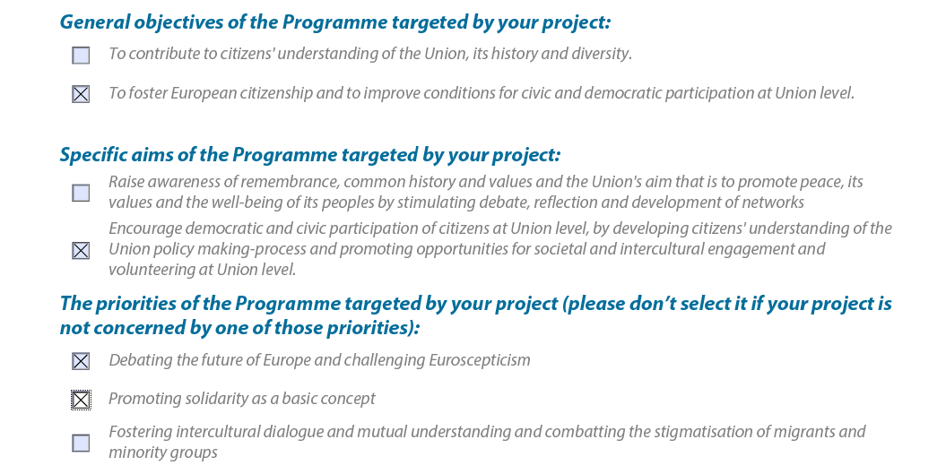

PLANNED ACTIVITIES: in LATVIA - KANDAVA AND OTHER BEAUTIFUL CITIES AROUND (KULDĪGA, TALSI, TUKUMS, ENGURE)

Day 1. Introductory round table: "How do I feel EU"

Day 2. Workshop "From Me to Ursula von der Leyen". Steps for approaching State, EU institutions. Being in opposition to the state institution (defending common values - definition, tactics, strategy, decision making). Examples. Group work. Moderators: experts (2) *dr.iur or dr.pol.*

Day 3. Activity complex "Justice in Europe": visit to a local district court (meeting with the judge); discussion on the most famous court decisions by ECJ, Constitutional Courts of member states (on such topics as: notion of family; social benefits; employment; free movement of goods/persons; elections). Moderators: experts (2)   *dr.iur or dr.pol.*

Day 4. Activity complex "Solidarity is not passive!" Seminar on various ways for possible engagement in voluntary work; promoting the idea of solidarity in local/international communities. Discussion on latest examples in Europe: solidarity with vulnerable groups; solidarity for defending European values; common action fighting for/ reacting on situation/problem (including social media).  Moderators: experts (2)   *dr.iur or dr.pol/ or practicioners.*

Day 5. Training workshop "Believe it or not!" Group work on analysing recent scandals/books/ articles/videos in EU member states shaking the society (corruption; secret organisations; conflicts with state institutions; ideological arguments; economic solutions; populism). Analysis. Critical thinking. Double-check of sources of information. Group work. Moderators (2): expert *communication science/sociology/ journalism.*

Final round table: "Next steps for influencing the policy: from local to European level". Lobbying. Legal regulation. Competence. Sharing experience of different EU countries. Group work. Moderators (2): expert *communication science/sociology/ journalism.*