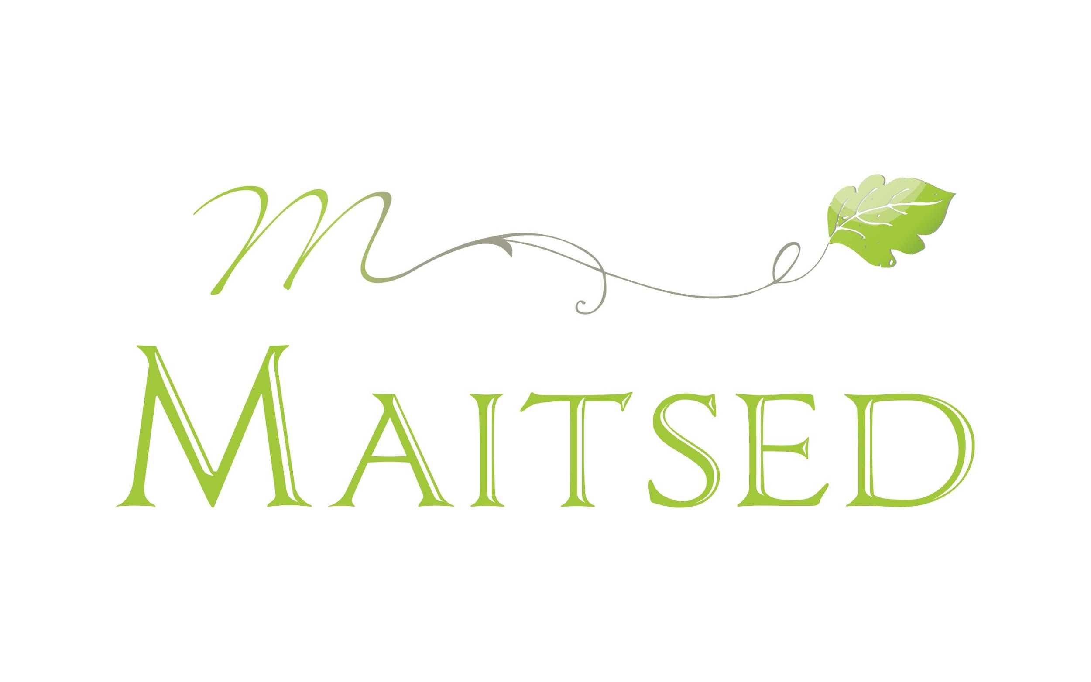WEEK MENU

October 20-24

|  |  |  |  |
| --- | --- | --- | --- |
|  | **BREAKFAST** | **LUNCH** | **DINNER** |
| MONDAY | 4- cereal porridge, jam, milk | Chicken goulash (P), rice, grated carrot, bread, apple  V: Vegetable wok  M: Chicken sauce with oat cream | Muesli, berry yogurt |
| TUESDAY | Millet porridge, berries, milk | Vegetable-pork soup (L/G), bread, white bread pudding, milk, carrot snack  V: Vegetable soup  P: Vegetable soup with beef | Rye bread with ham and cucumber, banana |
| WEDNESDAY | Oatmeal porridge, jam, milk | Fresh cabbage-minced meat stew (M/G), potatoes, pickled cucumber slices, bread, pear  V: Braised cabbage with kidney beans  P: Cabbage with beans and chicken | Lasagna with minced chicken (P) |
| THURSDAY | Rye-flake porridge, jam, milk | Creamy salmon soup (P/G), bread, cottage cheese mousse with jam, cabbage snack  V: Vegetable soup with lentils | Wrap with turkey and cheese (P) |
| FRIDAY | Barley-flake porridge, jam, milk | Vegetable ragout (V/G), beetroot-cabbage salad, bread, flavored water with berries, mandarin | Cheese roll, milk |

M L- lactose-free, casein-free

G F- grain-free (does not contain wheat, rye, barley or oat flour)

V- vegan

P-pork free