WEEK MENU

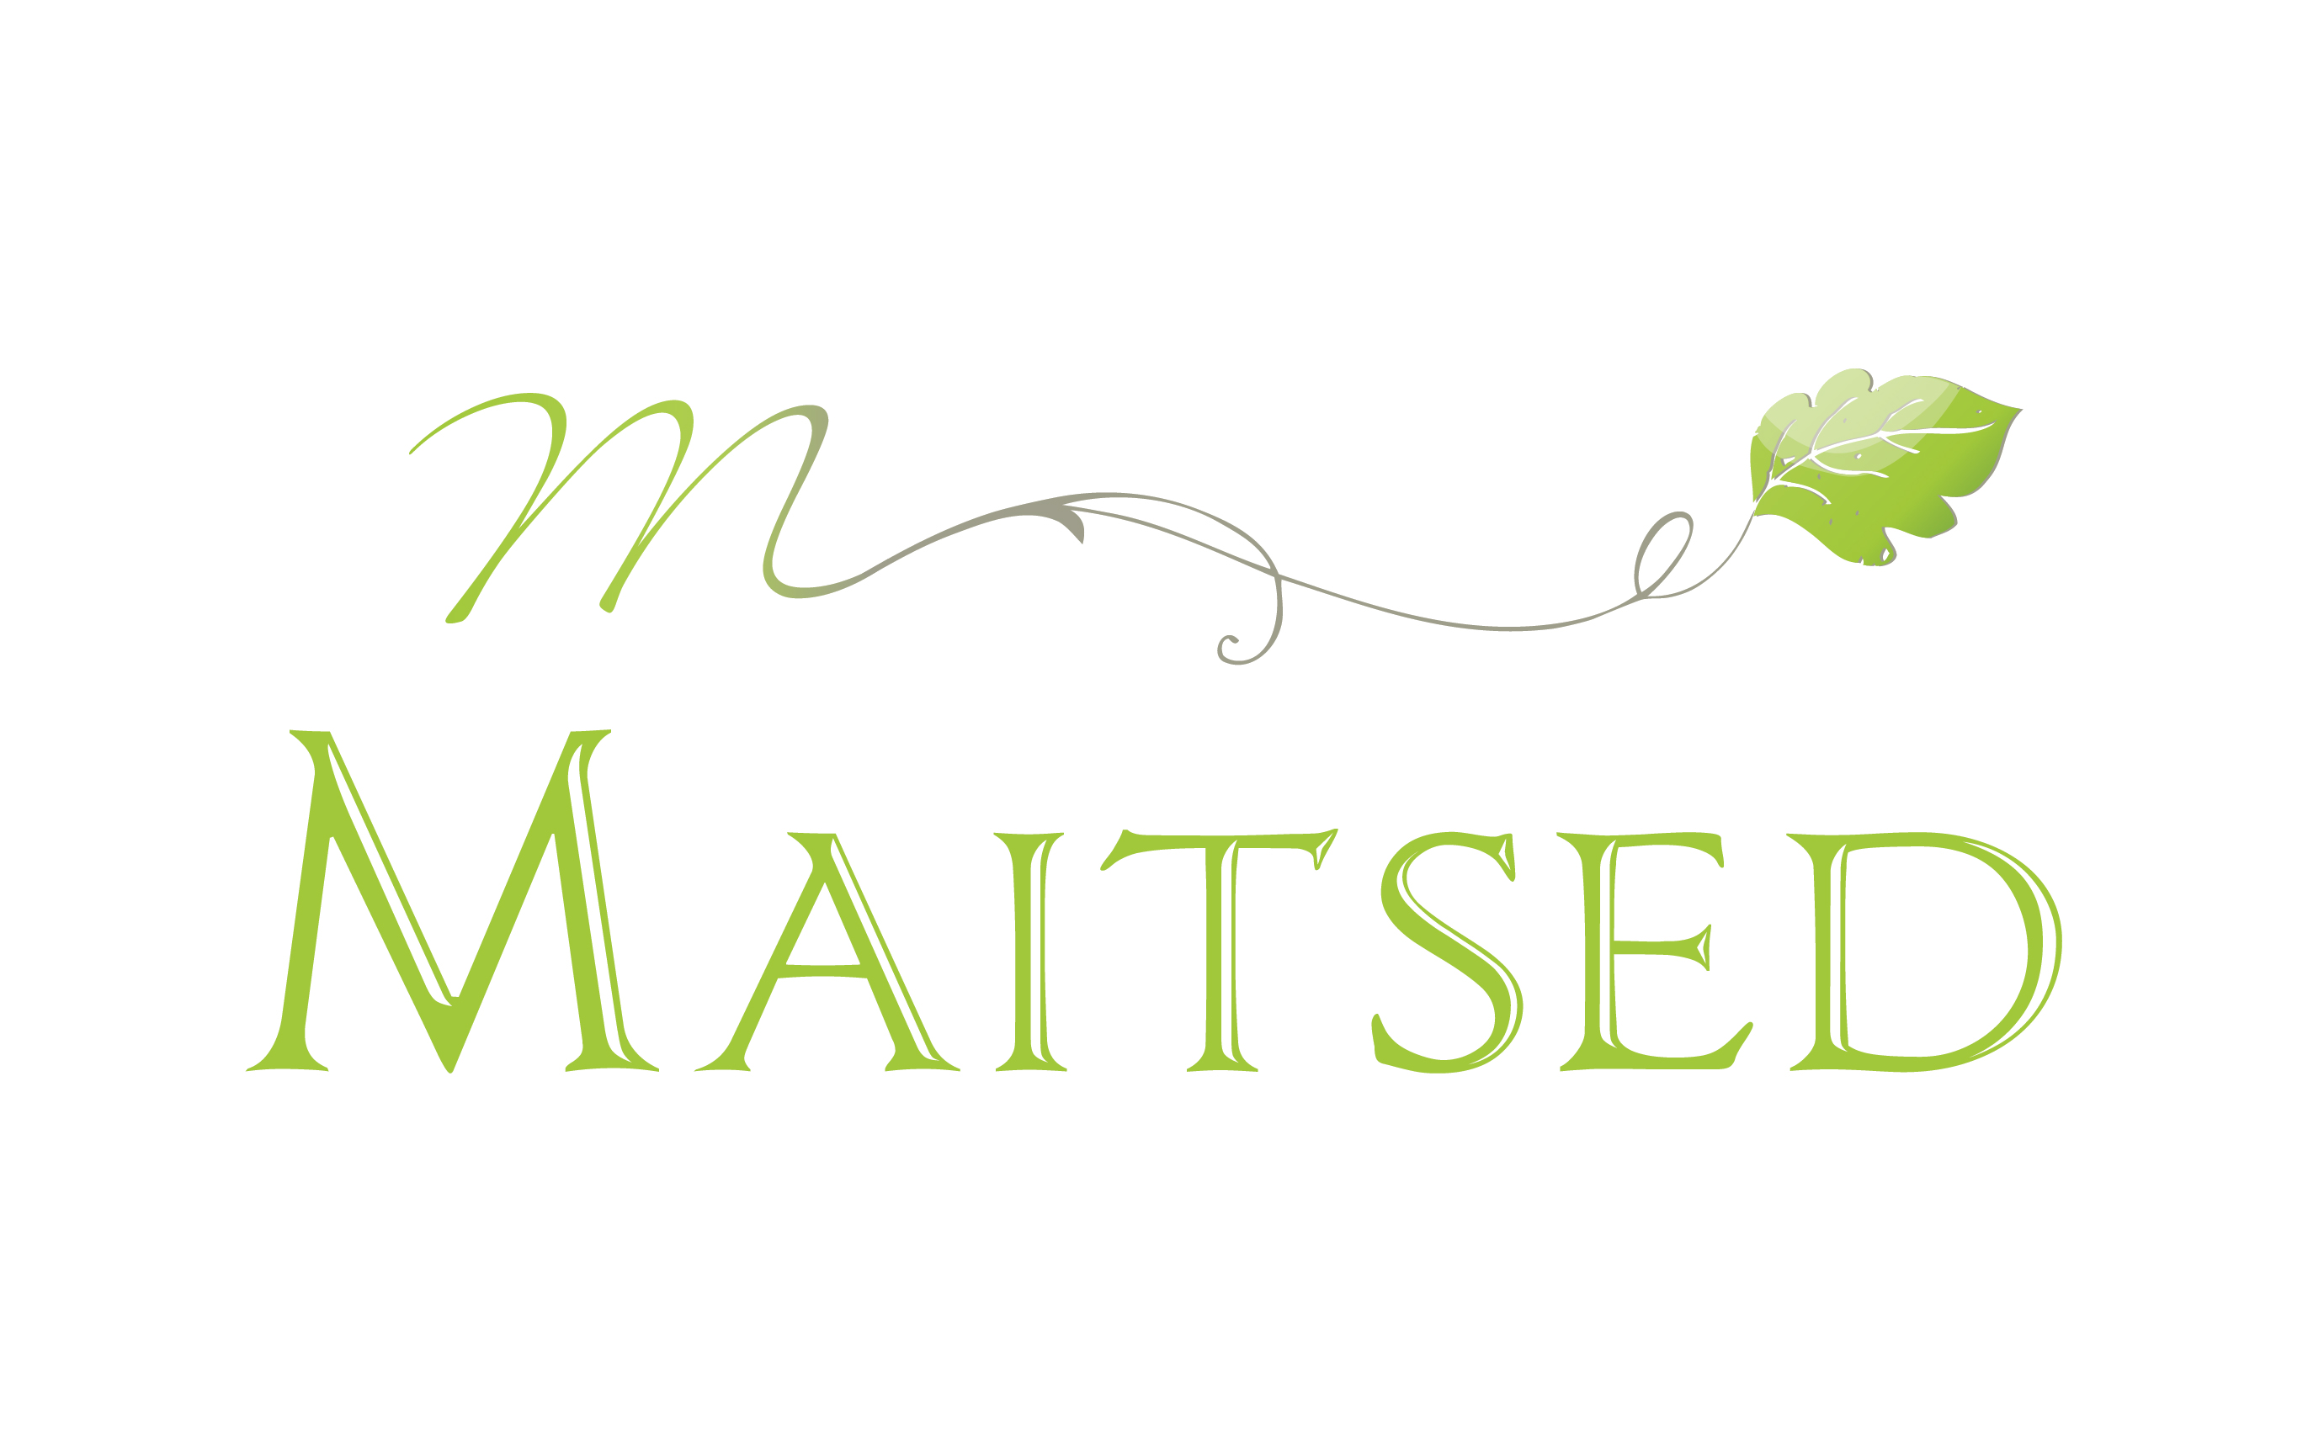

16.-20.02.26

 | BREAKFAST | SNACK | LUNCH | DINNER
MONDAY | Four-grain cereal porridge, pear pieces, milk | Apple | P : Kikerhernekaste kanaga, kaerakoor  Creamy chicken sauce with carrots (P), cabbage and paprika salad, bread, water/milk  V : Chickpea sauce  M : Chickpea sauce with chicken, oat cream | Scrambled eggs, bread  V: Hummus sandwich
TUESDAY | Corn semolina porridge, seeds, milk | Pear | SHROVE TUESDAY  Pea soup with smoked meat, bread, Shrove bun with whipped cream  V/P: Pea soup, bun with oat foam | Curd casserole with jelly  V: Rice porridge with jelly
WEDNESDAY | Rice porridge, butter, milk* | Apple | Homemade cutlets with beetroot, mashed potatoes, turnip salad with sour cream, bread  V/P: Vegetable cutlets, boiled potatoes, salad | Vegetable puree soup, bread
THURSDAY | Wheat cereal porridge, berries, milk | Banana | Fish soup (P), bread, berry smoothie  V: Vegetable soup with lentils | Fusilli pasta with tomato-herb sauce (V)
FRIDAY | Rye cereal porridge, jam, milk | Pear | Pilaff with minced chicken (M/P), tomato slices, bread, kefir  V: Vegetable rice stew | Carrot pie
M L- lactose-free, casein-free
G F - gluten-free (does not contain wheat, rye, barley or oat flour)
V- vegan (may contain egg)
P-pork free

