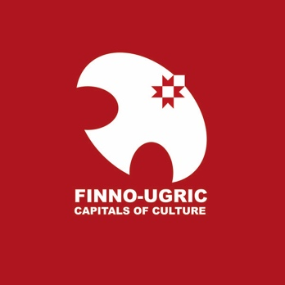

FINNO-UGRIC CAPITAL OF CULTURE 2025: SELECTION PROCEDURE
In accordance with Article 4.4.3 of the Statutes of the Finno-Ugric Capitals of Culture programme (hereafter: Statutes), URALIC Centre NGO (www.uralic.org) – as the coordinator of Finno-Ugric Capitals of Culture programme - hereby specifies the procedure and timeline for selecting the Finno-Ugric Capital of Culture 2025.
- Eligible candidates
All Finno-Ugric countries and regions except are eligible to apply for the title of Finno-Ugric Capital of Culture 2025, except national capitals or regional capitals in the case of the Russian Federation.
- Special theme: Renewal of the Finno-Ugric movement
Programme bureau of the Finno-Ugric Capitals of Culture encourages all applicants to reflect how the year of the Finno-Ugric capital of culture could provide venues and opportunities for thoughtful and creative exchanges on how Finno-Ugric cooperation and civic movement can survive, evolve and renew itself despite the current geopolitical challenges and in a situation where past Finno-Ugric institutions, such as the World Congresses of Finno-Ugric peoples, may be outdated. Even though the idea of Finno-Ugric solidarity and cooperation remains as strong and relevant as ever.
- Partners
URALIC Centre is conducting the competition for the title of Finno-Ugric Capitals of Culture 2025 in partnership with Sukukansojen Ystävät ry (Finland) and the Finnish-Hungarian Society.
Selection Jury
The five-member international and independent jury will be selected by 1 May, 2024.
- Timeline
Selection of Finno-Ugric Capital of Culture 2025 will take place according to the following timeline:
- March 4, 2024: Official announcement of the competition. Application materials are published and downloadable on Finno-Ugric Capitals of Culture website (www.uralic.org/projects/capitals/downloads)
- March 4 – April 30, 2024. Communication and PR. Preparation of applications.
- April 30, 2024: Final deadline for submission of applications to the Programme Bureau of Finno-Ugric Capitals of Culture (see 5. Programme Bureau). Applications must be sent only electronically (in PDF format) to capitals@uralic.org .
- May 1 – 14, 2024: Evaluation of applications by the Selection Jury (for more detailed procedure, see 4. Rules of Selection)
- May 15, 2024 - Announcement of finalists (max 3) of the competition
- June 29, 2024: 2nd round presentations for up to 3 finalists to be held in Kuhmo, Finland. Public announcement of the winner of the title „Finno-Ugric Capital of Culture 2025“

- Rules of Selection
Finno-Ugric Capital of Culture 2025 will be selected by the Jury based on two (2) rounds of selection. In both rounds, no formal selection criteria are applied; jury members are encouraged to use their own personal judgement about the quality of applications. However, members of the Jury are asked to take into account the general selection criteria listed under Article 4.3. of the Statutes. The two rounds will be conducted as follows:
- In Round 1, jury members independently rank all applications from 1 to N (N=number of eligible applications) where „1“ refers to the most competitive and „N“ to the least competitive application. Based on that, Programme Bureau calculates arithmetic averages of the rankings of all applications. Three applications with the highest average ranks are selected for Round 2. However, Selection Jury can decide to extend the number of applications selected to Round 2 to more than three.
- In Round 2, selected applicants (up to three) will be invited to prepare presentations to be delivered in person at a special public event on June 29, 2024, to be held in Kuhmo, FInland. Therafter, jury will privately convene and select the winner. Results of the competition will be publicly announced on the same day.

- Secretariat

The Secretariat of the Finno-Ugric Capitals of Culture is headed by URALIC Centre NGO (URALIC KESKUS MTÜ), registered in Otepää, Estonia, based on a mandate from the Youth Association of Finno-Ugric Peoples (MAFUN).

Contact information: Tel. +372 513 2992 capitals@uralic.org

