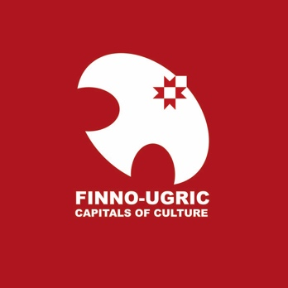

FINNO-UGRIC CAPITAL OF CULTURE 2024: SELECTION PROCEDURE
In accordance with Article 4.4.3 of the Statutes of the Finno-Ugric Capitals of Culture programme (hereafter: Statutes), URALIC Centre NGO (www.uralic.org) , in association with the Youth Association of Finno-Ugric Peoples (MAFUN), hereby specifies the procedure and timeline for selecting the Finno-Ugric Capital of Culture 2024.
- Eligible candidates
In accordance with Article 5 (Ensuring Diversity of Capitals of Culture) of the Statutes and as a result of the title of Finno-Ugric Capital of Culture 2023 having been awarded to Finland, all Finno-Ugric countries and regions except Finland are eligible to apply for the title of Finno-Ugric Capital of Culture 2024.
- Special theme: Future of the Finno-Ugric movement
Programme bureau of the Finno-Ugric Capitals of Culture encourages all applicants to think of ways how the year of the Finno-Ugric capital of culture could provide venues and opportunities for frank, thoughtful and mutually respectful exchanges on how Finno-Ugric cooperation and civic movement can continue to exist and develop despite the current geopolitical challenges.
Selection Jury
The five-member jury will be selected by 15 March, 2023.
- Timeline
Selection of Finno-Ugric Capital of Culture 2024 will take place according to the following timeline:
- February 24, 2023: Official announcement of the competition in Kuhmo – Finno-Ugric Capital of Culture 2023. Application materials are published and downloadable on Finno-Ugric Capitals of Culture website (www.uralic.org/projects/capitals/downloads)
- February 24 – March 31, 2023. Communication and PR. Preparation of applications.
- March 31, 2023: Final deadline for submission of applications to the Programme Bureau of Finno-Ugric Capitals of Culture (see 5. Programme Bureau). Applications must be sent only electronically (in PDF format) to capitals@uralic.org .
- April 1 – 10, 2023: Evaluation of applications by the Selection Jury (for more detailed procedure, see 4. Rules of Selection)
- April 11, 2023 - Announcement of finalists of the competition (max 3)
- April 14, 2023: 2nd round presentations for up to 3 finalists to be held in Otepää, Estonia (hybrid offline + online format).
- April 14, 2022: Public announcement of the winner of the title „Finno-Ugric Capital of Culture 2024“

- Rules of Selection
Finno-Ugric Capital of Culture 2024 will be selected by the Jury based on two (2) rounds of selection. In both rounds, no formal selection criteria are applied; jury members are encouraged to use their own personal judgement about the quality of applications. However, members of the Jury are asked to take into account the general selection criteria listed under Article 4.3. of the Statutes. The two rounds will be conducted as follows:
- In Round 1, jury members independently rank all applications from 1 to N (N=number of eligible applications) where „1“ refers to the most competitive and „N“ to the least competitive application. Based on that, Programme Bureau calculates arithmetic averages of the rankings of all applications. Three applications with the highest average ranks are selected for Round 2. However, Selection Jury can decide to extend the number of applications selected to Round 2 to more than three.
- In Round 2, selected applicants (up to three) will be invited to prepare presentations to be delivered in person or online at a special public event on April 14, 2023, to be held in Otepää, Estonia (location of the Secretariat). Therafter, jury will privately convene and select the winner. Results of the competition will be publicly announced on the same day.

- Secretariat

The Secretariat of the Finno-Ugric Capitals of Culture is represented by URALIC Centre NGO (URALIC KESKUS MTÜ), registered in Otepää, Estonia, based on a mandate from MAFUN.

Contact information of the Programme Bureau (including for further questions and for submission of applications): capitals@uralic.org

