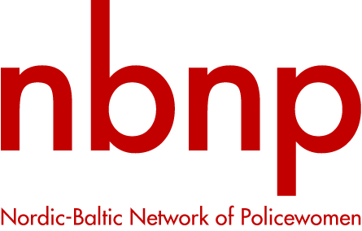

NBNP ACTION PLAN 2017-2019

Nordic-Baltic Network of Policewomen (NBNP) is a Non-Profit International Network. NBNP was constituted in Riga, Latvia, in April 2001.

NBNP COMMON CORE STATEMENT
NBNP works to strengthen gender equality and diversity within the police organisations and NBNP makes a difference, because NBNP focus on issues from a gender and police perspective, in order to give the activity processes an added value and resulting in a positive change.

The NBNP OBJECTIVES during 2018-2019 IN ALL MEMBER COUNTRIES
- The main purpose of NBNP is cooperation between the countries, networking, sharing of experience and knowledge
- The main common goal of NBNP is gender equality and equal opportunities for both men and women in the police force and combating gender related crimes
- The goal of NBNP is to promote activities in Nordic and Baltic societies especially within the national police

NBNP CORE ACTIVITIES
- NBNP will conduct projects aiming at fulfilling NBNP´s objectives and when relevant in cooperation with other stakeholders
- NBNP will arrange conferences, seminars and meetings to achieve the main objectives of the NBNP
- NBNP will collect facts, share information and present news through social media and NBNP web-page

NBNP ACTIVITIES in 2018-2019 shall reflect the objectives of NBNP´s constitution. The NBNP activities in will focus on 2018-2019:
1. Women in the Police
- follow-up the conclusions from the Women in the Police seminar in Riga 2017
- outline a project focusing on gender mainstreaming in the police

2. Gender Related Crimes
- violence against women
- hate crimes
- human trafficking

3. Continue to apply funding for projects

4. Cooperation by taking few steps within the frame of the existing resources and support.

