THE INTRODUCTION OF THE METHODOLOGY FOR THE DEVELOPMENT OF THE ICT CURRICULUM

Version | Amended by | Date | Amendment
5.0 | Erkki Leego | 2017-10-18 | Methodology prepared for testing.

- Introduction 1
  - The purpose 1
  - The background 1
  - The principles of development of the curriculum 2
  - The four main documents drawn up in the course of the development process 2
- An overview of the process of development of the ICT curriculum 2
  - The programme manager prepares the materials for changing the curriculum 3
  - The employer’s representative complements the profile of competencies of the curriculum 3
  - The programme manager draws up the compliance analysis of the curriculum and proposes changes 3
  - The employer’s representative provides feedback to the proposed changes of the curriculum 3
  - The programme manager draws up a plan of changes based on the required changes 3
  - The programme council makes the decisions on the required changes 3
  - The programme manager coordinates implementation of the changes 3
- The instructions for drawing up the documents 4
  - The overview of the curriculum 4
  - The profile of competencies of the curriculum 4
  - Analysis of the compliance of the curriculum 6
  - The plan of changes 7
- Overview of the support materials 8
  - The European e-Competence Framework (e-CF) 8
  - The Fontes catalogue of the job families in the ICT sector 9
  - The Estonian professional ICT standards 10

Introduction

The purpose
The purpose of the methodology is to aid the employer’s representative in contributing to the development of the ICT curriculum so that increased consideration can be paid to the requirements of the employment market.
The purpose of the process that is described in the methodology is to reach an agreement on which changes should be made in the curriculum and in the subjects by basing this on the needs (competencies) of the employment market.

The background
This methodology was drawn up in summer and autumn 2017, with the work being led by HITSA within the framework of the IT Academy programme. Key representatives of employers and universities were actively involved in the process.
One of the strategic goals of the IT Academy programme for the 2016-2020 period is to develop the ICT curricula in order to provide an opportunity for students so that they can study at the international level and also so that they may study curricula which have been accepted
by employers, provide the skills so that they can implement what they have learned, and also so that they can meet the needs of the economy.

The principles behind the development of the curriculum
    - The curriculum’s development is focussed upon ensuring the competencies that are required in the employment market by means of curriculum learning outcomes and the subjects that are included within it.
    - The curriculum’s competencies and its subjects are selected and phrased by basing them on the European e-Competencies Framework (e-CF). The main competencies must be phrased by using performance-based indicators, and the connection with the Dimension 2 competencies of the e-CF must be highlighted.
    - The programme manager is responsible for the development of the curriculum.

The four main documents for the development process
- The curriculum overview provides an overview of the necessity for and content of the curriculum and of the need for changes.
- The profile of the curriculum’s competencies describes the expectations of the employment market when it comes to the curriculum.
- The curriculum’s compliance analysis describes the compliance of the curriculum with the expectations of the employment market and any changes which would serve to reduce the difference between the two.
- The plan of changes provides an overview of changes that have been agreed in the process of developing the curriculum.

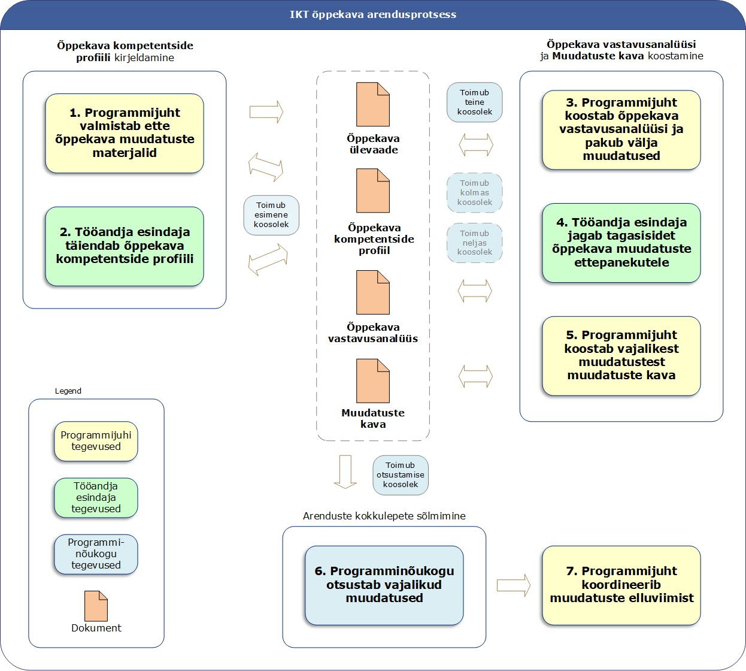
An overview of the process of developing the ICT curriculum
5. The programme manager draws up the plan of changes which is based upon the changes that may be required
3. The programme manager draws up the curriculum’s compliance analysis and proposes any changes that may be required
1. The programme manager prepares the materials for making changes to the curriculum
Drawing up the compliance analysis and the plan of curriculum changes curriculum
The process of d A description of the profile of competencies for the curriculum eveloping the ICT curriculum
The process of developing the ICT curriculum
The fourth meeting is held
The third meeting is held
The second meeting is held
The first meeting is held
The compliance analysis for the curriculum
The profile of curriculum competencies
Reviewing the curriculum
The decision-making meeting is held
The plan of changes
The decision-making meeting is held
6. The programme council reaches a decision regarding the required changes
The activities of the programme council
Actions to be taken by the employer’s representative
Document
4. The employer’s representative shares the feedback on the proposed changes to the curriculum
2. The employer’s representative complements the profile of curriculum competencies
The programme manager’s activities
7. The programme manager coordinates the implementation of the changes

Development stage | Member of the programme council | Programme manager
- The programme manager prepares the materials for changing the curriculum  Estimated volume of the work: 16 hours  Estimated duration: 2 weeks | Provides notification as soon as possible of suitable times for them to participate in the meeting.  Gets acquainted with the materials that are sent by the programme manager.  Takes part in the programme council meeting.  Undertakes an obligation with respect to further work. | Draws up an overview of the curriculum.  Draws up a draft of the programme council’s action plan and schedule.  Draws up a draft of the profile of competencies for the curriculum.  Holds the first programme council meeting and introduces:  • the methodology  • the curriculum  • the profile of competencies  • the action plan  Coordinates agreement on the action plan and the distribution of duties of the programme council.
2.2 The employer’s representative complements the profile of competencies for the curriculum  Estimated volume of the work: 8 hours  Estimated duration: 1 week | Complements the profile of competencies for the curriculum, involving external experts if necessary.  Carries out other work that has been agreed in the distribution of duties if this proves necessary. | Supervises the work of the programme council.  Complements the overview of the curriculum.
2.3 The programme manager draws up the compliance analysis for the curriculum and proposes changes  Estimated volume of the work: 16 hours  Estimated duration: 2 weeks | Provides explanations for the profile of competencies of the curriculum, if necessary.  Takes part in further discussions, if necessary. | Draws up the analysis of curriculum’s compliance.  Describes the proposed changes for the curriculum and subjects.  Complements the overview of the curriculum.  Forwards the materials and requests for feedback to the members of the programme council.
2.4 The employer’s representative provides feedback on the proposed changes for the curriculum  Estimated volume of the work: 8 hours  Estimated duration: 1 week | Analyses the compliance analysis that has been drawn up by the programme manager along with the proposed changes.  Provides feedback and makes suggestions.  Participates in further discussions, if necessary. | Provides further explanations regarding the curriculum and the proposed changes, if necessary.
2.5 The programme manager draws up a plan of changes based on those changes that are required  Estimated volume of the work: 12 hours  Estimated duration: 1 week | Provides suggestions and further explanations on the feedback, if necessary. | Complies the feedback that has been gathered.  Makes proposals for decisions concerning all of the proposed changes in the curriculum’s compliance analysis.  Draws up the plan of changes.  Makes preparations for the programme council’s decision-making meeting.
2.6 The programme council reaches decisions regarding the required changes  Estimated volume of the work: 4 hours  Estimated duration: 1 week | Takes part in the programme council meeting.  Forms an opinion on the materials that have been submitted. | Holds the programme council meeting.  Introduces the following documents:  - the overview of the curriculum  - the profile of competencies for the curriculum  - the curriculum’s compliance analysis  - the plan of changes  Formalises the decisions of the programme council and the final versions of the documents.
2.7 The programme manager coordinates the implementation of the changes  The volume of the work depends on the number of changes.  Estimated duration: 1 month | Provides advice on the implementation of the changes.  Exhibits interest in the successful implementation of the changes. | Coordinates the implementation of the changes.  Introduces the methodology to those persons who are responsible for providing the descriptions of the subjects.  Notifies the employer’s representative of the progress of the implementation of the changes, and includes any significant obstacles which may arise.

The instructions for drawing up the documents

The overview of the curriculum
The advised structure:
- Justification of the necessity of the curriculum, including the following:
  - whether it is up-to-date and compliant with developments in the field
  - the need for and the focus of the jobs
  - the position, with respect to other ICT curricula and in the e-CF ICT business process (see subsection 4.1)
- The purposes of the curriculum, the learning outcomes, and the general structure
- A brief analysis of the curriculum, including:
  - conclusions based on feedback received and on the statistical information about the curriculum
  - the most significant development activities and needs
- A summarising table showing the positions of the curriculum’s competencies in the e-CF Dimensions 1 and 2

The profile of curriculum competencies
Competency is classed as being a set that comprises knowledge, skills, and attitudes that are expressed in the action, all of which are a prerequisite for the successful performance of one’s duties. It describes what a person is capable of doing.
The main competencies must be formulated by using a performance indicator, and the connection with the Dimension 2 competencies of the e-CF Framework must be highlighted. For example, the descriptive categories that are used in e-CF Dimension 2 can be used - ‘Integrating hardware and software components into the new system (e-CF competency B.2)’.
The description of a main competency must specify to what extent or at which level of complexity the competency must be acquired:
- Low – possesses knowledge
- Medium – able to implement in a team
- High – able to implement independently.
In selecting the competencies that may arise from staff positions, it is recommended that the ICT profiles be used where they are related to the e-CF (see subsection 4.1), along with the descriptions of the staff positions in the catalogue of the Fontes job families (see subsection 4.2), and the Estonian professional standards (see subsection 4.3). It is also possible to use a so-called online tool to choose the competencies (see subsection 4.1).
The performance indicators for the competencies may be specified by using descriptions of skills and knowledge (e-CF Dimension 4).

An example of the structure of a profile of competencies:
---------------------------------------------------------------------------------------------------------
Curriculum name: Master’s level curriculum: ‘Information Science (129537)’ at the University of Tartu, 2017/2018
Curriculum purpose: to prepare senior information science specialists for public authorities and commercial undertakings.
Current curriculum learning outcomes. A student who has completed the curriculum:
- has acquired the core knowledge that is required in the field of information science and is able to implement that knowledge to be able to analyse and solve practical problems;
- possesses in-depth levels of knowledge on one of the narrower fields of computer science and of the disciplines which are closest to the field;
- can conduct independent research work on a topic that has been set by the supervisor and present the outcomes in a proper and comprehensible manner.

The main focus of job positions
- CIO, business analyst (European ICT profiles)

The main competencies
Competency |  |  | (e-CF) | Performance indicator for the competency | Level
A.1. IS and Business Strategy Alignment |  |  |  | Assesses the strategic business needs of the organisation and develop the organisation’s processes towards effectiveness and efficiency. | Medium
A.1. IS and Business Strategy Alignment |  |  |  | Describes the information system which meets the organisation’s needs and the architecture of that information system. | Medium
A.1. IS and Business Strategy Alignment |  |  |  | Makes strategical IT decisions within the organisation.  - Will be familiar with the main IT standards and the frameworks of good practice | Low
A.3. Business Plan Development |  |  |  | Describes the options to be able to meeting the organisation’s business needs.  - Able to conduct an expense analysis | Low
A.3. Business Plan Development |  |  |  | Plans service purchasing. | Low
A.3. Business Plan Development |  |  |  | Ensures the compliance of the technology with business needs. | Low
A.3. Business Plan Development |  |  |  | Communicates the business plan to involved parties. | Low
D.11. Needs identification |  |  |  | Maps out the needs of the internal and external stakeholders. | High
D.11. Needs identification |  |  |  | Suggests solutions which meets the needs of the stakeholders. | Medium
E.2. Project and Portfolio Management |  |  |  | Implements the plan of changes | Medium
E.2. Project and Portfolio Management |  |  |  | Plans and manages IT projects. | High
E.2. Project and Portfolio Management |  |  |  | Draws up the action plan for the project. | Medium
E.2. Project and Portfolio Management |  |  |  | Analyses and manages project risks. | Low
E.4. Relationship Management |  |  |  | Manages positive relations with significant and external parties. | Medium
E.4. Relationship Management |  |  |  | Ensures understanding with and the management of the needs of and problems faced by the involved parties, and feedback received from those parties, based on the organisation’s rules. | Medium
E.5. Process Improvement |  |  |  | Measures the efficiency of the ICT processes. | Medium
E.9. | IS | Governance |  | Defines, implements, and inspect the management of the information system. | Low
E.9. | IS | Governance |  | Takes into consideration the internal and external requirements and restrictions to ensure optimum benefits to the business.  - Will be familiar with the main IT-related regulations | Low
…

The recurring competencies:
- Communication skills
- Verbal and written expression skills
- Professional ethics
- Teamwork skills
- Problem-solving skills
- Organising the work based on deadlines
- Ability to develop oneself

An overview of the main competencies based on the e-CF Dimensions 1 and 2
A. PLAN | B. BUILD | C. RUN | D. ENABLE | E. MANAGE
A.1. IS and Business Strategy Alignment | B.1. Application Development | C.1. User Support | D.1. Information Security Strategy Development | E.1. Forecast Development
A.2. Service Level Management | B.2. Component Integration | C.2. Change Support | D.2. ICT Quality Strategy Development | E.2. Project and Portfolio Management
A.3. Business Plan Development | B.3. Testing | C.3. Service Delivery | D.3. Education and Training Provision | E.3. Risk Management
A.4. Product / Service Planning | B.4. Solution Deployment | C.4. Problem Management | D.4. Purchasing | E.4. Relationship Management
A.5. Architecture Design | B.5. Documentation production |  | D.5. Sales Proposal Development | E.5. Process Improvement
A.6. Application Design | B.6. Systems Engineering |  | D.6. Channel Management | E.6. ICT Quality Management
A.7. Technology Trend Monitoring |  |  | D.7. Sales Management | E.7. Business Change Management
A.8. Sustainable Development |  |  | D.8. Contract Management | E.8. Information Security Management
A.9. Innovation |  |  | D.9. Personnel Development | E.9. IS Governance
 |  |  | D.10. Information and Knowledge Management
 |  |  | D.11. Needs Identification
 |  |  | D.12. Digital Marketing
End of the example. ------------------------------------------------------------------------------------

Analysis of the curriculum’s compliance
The purpose of the curriculum’s compliance analysis is to assess the difference between the needs of the employment market (in terms of competencies) and what is taught in the curriculum (the learning outcome), and to plan changes which reduce the differences between the two.
The column labelled ‘Competency’ will include all competencies from the profile of the curriculum’s competencies. The ‘Compliance’ column will specify whether the specific competency is acquired and how that is done within the framework of the curriculum:
    - An overview regarding in which subject the specific competency is developed and what the learning outcomes may be for each subject.
    - A description of the learning outcome for the subject in which the competency is acquired or an explanation of how the competency is developed by the subject;
    - In the case of there being a lack of compliance, the comment ‘No suitable subject in the curriculum’ is used.
    - In the case of there existing a Master’s curriculum, it must be specified to which extent the competency was acquired in the subjects of the Baccalaureate-level curriculum.
The ‘Suggestion/feedback’ column includes suggestions which cover changes and feedback from the members of the programme council and also later notes for implementing any accepted changes.
In general, a proposal for a change is one of the following four:
- To change the learning outcomes of the curriculum;
- To change the learning outcomes of the subject;

- To add a new subject to the curriculum;
- To remove a subject from the curriculum.
Those subjects that are included in the curriculum which are not connected to any of the competencies that are included in the profile of competencies must be highlighted separately, with no compliance being specified in the ‘Compliance’ column of the compliance analysis. The need for and role of such subjects must be analysed separately.
An example of the structure of a compliance analysis is as follows:

Competency | e-CF | Compliance | Suggestions/ feedback | Decision
Conducting the development process | B.1 | Taught in the subject ‘MTAT.03.266 Creating mobile applications. The project’, but not described by the learning outcomes  Taught in the subject ‘MTAT.03.278 The software business project’ (12 EAP), which is not compulsory | PJ: The learning outcomes for the subjects must be complemented  TE: Okay. | PN: 2017-09-10  Meeting decision: the learning outcome of the subject, MTAT.03.266,  to be complemented to ensure compliance with e-CF B.1.
Communication skills |  | There are numerous research projects in the curriculum which require teamwork and communication skills

The plan of changes
The plan of changes is a brief overview of the curriculum’s compliance analyses, which must highlight the following:
- Competencies for which development is well-covered;
- The main issues and needs involved in the development of the curriculum;
- The planned development activities.
Detailed descriptions of the changes can be found in the curriculum’s compliance analysis (in the ‘Suggestions/feedback’ and ‘Decision’ columns).

If there is a will, there is a way!

Overview of the support materials

The European e-Competence Framework (e-CF)
The pan-European framework of ICT competencies (the European e-Competence Framework) which has been established as a standard in Estonia.
The framework describes the competencies in four dimensions:
    - Dimension 1 - five areas of e-competencies
    - Dimension 2 – forty sets of e-competencies
    - Dimension 3 – five levels of competencies for distinguishing between the competencies of Dimension 2
    - Dimension 4 – examples of the knowledge and skills to specify Dimension 2
The valid version of the framework, v3.0, and the guidelines can be downloaded free of charge via: http://www.ecompetences.eu/e-cf-3-0-download/.
Online electronic tools can be found at http://www.ecompetences.eu/career- and-assessment-tools-3/. The e-CF Profiling Tool is the best option.
e-CF Dimensions 1 and 2 are used in drawing up Estonian professional standards.

An overview of the E-CF competencies (Dimensions 1 and 2):

A. PLAN | B. BUILD | C. RUN | D. ENABLE | E. MANAGE
- IS and Business Strategy Alignment  - Service Level Management  - Business Plan Development  - Product / Service Planning  - Architecture Design  - Application Design  - Technology Trend Monitoring  - Sustainable Development  - Innovation | - Application Development  - Component Integration  - Testing  - Solution Deployment  - Documentation Production  - Systems Engineering | - User Support  - Change Support  - Service Delivery  - Problem Management | - Information Security Strategy Development  - ICT Quality Strategy Development  - Education and Training Provision  - Purchasing  - Sales Proposal Development  - Channel Management  - Sales Management  - Contract Management  - Personnel Development  - Information and Knowledge Management  - Needs Identification  - Digital Marketing | - Forecast Development  - Project and Port- folio Management  - Risk Management  - Relationship Management  - Process Improvement  - ICT Quality Management  - Business Change Management  - Information Security Management  - IS Governance
Within the cooperation of the European Committee for Standardisation (CEN), 23 professional profiles (European ICT Professional Profiles) have been described. See: http://www.ecompetences.eu/ict-professional-profiles/

The professional ICT profiles below have been described by using the e-CF competencies:

Business management | Technical management | Design | Development | Service & operation | Support
Business Information Manager  CIO  ICT Operations Manager | Quality Assurance Manager  ICT Security Manager  Project Manager Service Manager | Business Analyst Systems Analyst  Enterprise Architect  Systems Architect | Developer  Digital Media Specialist  Test Specialist | Database Administrator  Systems Administrator Network Specialist Technical Specialist Service Desk Agent | Account Manager  ICT Trainer  ICT Security Specialist  ICT Consultant

If there is a will, there is a way!

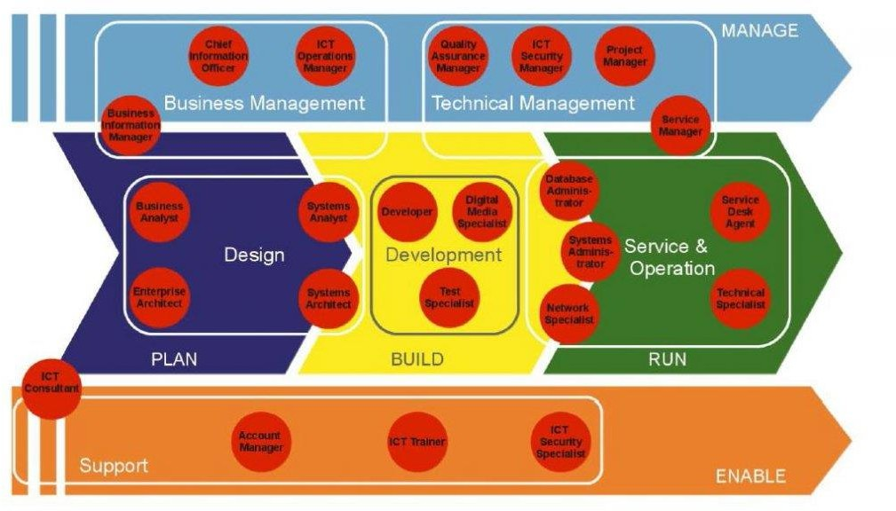
The positions of the professional ICT profiles in the business process where these are related to the e-CF Dimension 1 and based on the six job families:
The structure of the profiles for ICT roles in the Estonian language can be found via: https://startit.ee/skeem/.

The Fontes catalogue of job families in the ICT sector
The Fontes catalogue of job families is designed to serve as a tool for the (human resources) manager of an organisation in the systematic assessment of the job positions in the organisation. This is a method for using the value of a post which describes the content, main tasks, and responsibilities that are included in any specific employment post. The Fontes catalogue of job families is, above all, designed for use in the remuneration studies that are conducted by Fontes.
NB: The catalogue of job families is not publicly accessible. Negotiations are ongoing for permanent user rights in regard to the catalogue of job families as part of the process of developing the ICT curricula.
Depending upon the level of complexity, the job positions described in a job family are described in as many as five levels. In 2017, there were 25 job families in the Fontes catalogue of ICT job families.

An example of the ICT database administration job family:
The job family includes positions which are aimed at ensuring database administration, maintenance, and development. If a position fulfils both the duties of a system administrator and database administrator then the position in question is based upon the main competency or is based on those duties which form a larger part of the whole.
Job position | Competencies
ICT database administration III  Leading administrator, leading database expert | Designs and manages various large-scale databases or sets of those databases  Manages database development projects from planning to implementation Designs and plans the development of databases in the longer perspective  Develops the non-functionality requirements for databases in cooperation with other units (risk management)  Manages and coordinates the work of specialists  May participate in negotiations that are held with suppliers, and monitors the performance of contracts  May supervise the work of lower level specialists (in a small team)  Acknowledged experts in relation to respective solutions  Must have more than five years of work experience in the field

The Estonian professional ICT standards
If there is a will, there is a way!

The professional qualifications system is part of the Estonian qualification system which itself connects the educational system to the employment market and supports lifelong learning, as well as the development, assessment, acknowledgment, and a comparison of professional competence.
Descriptions of the professional standards can be found via the website of the Estonian Qualifications Authority (SA Kutsekoda): http://www.kutse koda.ee/et/kutseregister/kutsestandardid/otsing (field: IT, telecommunications, and electronics).

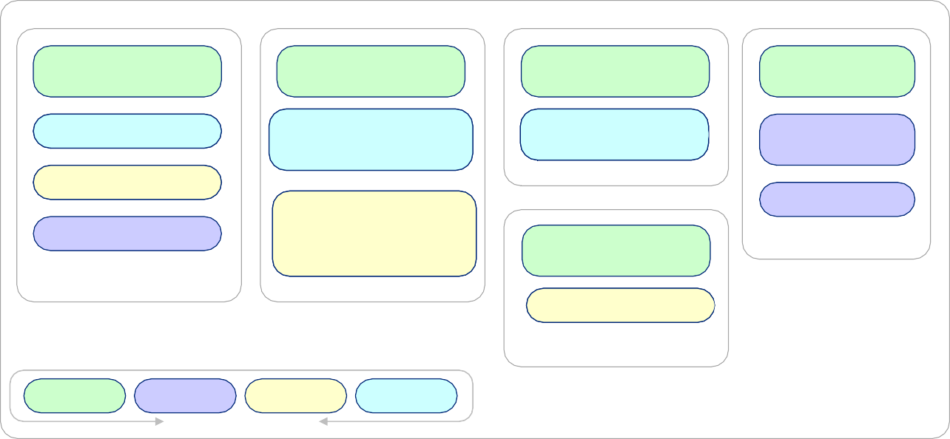
There are nine professional ICT standards, with six at the level of higher education:
Computer systems
Telecommunications
MAG
MAG
Information and telecommunication technolgy engineer,
level 7
BAKA
Senior information and telecommunication technology specialist, level 6
BAKA Software developer,
Professional standard Professional standard Professional standard
Vocational training level Baccalaureate-level Master’s level
Software development
IT systems and services
MAG
Software development engineer, level 7
Automated system engineer,
level 7
Junior IT system specialist, level 4
level 6
IT support person, level 3
Junior software developer, level 4
Electronics
BAKA
Security system designer, level 6
Legend
Profession

