THE CALEDONIAN SOCIETY OF FRANCE
BURNS’ DAY-2018
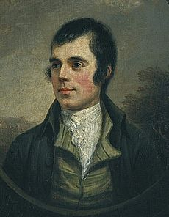
The Twinning Committee of Aubigny-sur-Nère has invited the Caledonian Society of France to join in their annual Burns’ Day celebration on Sunday 28th January 2018.
Our group will travel by coach departing from the Esplanade des Invalides (outside the Métro exit) at 09h00 and returning to Paris at around 21h30.
The organisation of the event is as follows:
12h30 Aperitif
13h00 Scottish meal: cock-a-leekie soup, haggis, neeps and tatties, cheese and oatcakes, pudding. (Wine extra)
15h30 Concert of Scottish music and songs with Joanne McIver (flute, penny whistle, bagpipes and vocals) and Christophe Saunière (harp and vocals)
16h30 Two hours of ceilidh dancing to live music
The price (transport included) is € 50,00 for members of the Society and € 60,00 for non-members.
The last date for bookings is Saturday 20th January 2018 at midday. As the number of places for the outing is limited to 55, early booking is essential to avoid disappointment.
THE CALEDONIAN SOCIETY OF FRANCE

Booking Form – Burns’ Day – 2018

Name(s) _________________________________________________________________________
__________________________________________________________________________________
__________________________________________________________________________________
__________________________________________________________________________________
Address(es) _ __________________
____________ _____________________________________
__________________________________________________________________________________
Telephone _______________________________________________________________________
e-mail ___________________________________________________________________________

Enclosed a cheque to the amount of € for participant(s) and made payable to ‘The Caledonian Society of France’.

This application form plus the corresponding remittance should be sent to Patrick Shuttlewood, Secretary – The Caledonian Society of France, 7 rue des Pierres, 92190 Meudon.

Members are reminded that bookings accompanied by the corresponding cheque must be submitted by Saturday 20th January 2018 at midday at the latest and that no refunds can be made after that date.

Important! If you are paying your annual subscription to the Society, please add the corresponding amount to your booking for Aubigny and submit only one cheque. Thank you!

