BURNS’ DAY-2020
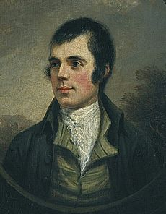
The Twinning Committee of Aubigny-sur-Nère has again invited members and friends of the Caledonian Society of France to join in their annual Burns’ Day celebration on Sunday 26th January 2020.
Our group will travel by coach departing from outside Invalides Métro station at 09h00 and returning to Paris at around 21h30.
The organisation of the event is as follows:
12h00 Aperitif
13h00 Scottish meal: cockie leekie soup, haggis, neeps and tatties, cheese and oat cakes, Scottish-inspired dessert. (Wine not included.)
15h30 Concert of Scottish music and songs with Joanne McIver (flute, penny whistle, bagpipes and vocals) and Christophe Saunière (harp and vocals)
16h30 Two hours of ceilidh dancing to live music
The price (transport + aperitif + lunch + concert + ceilidh) is € 50,00 for Society members and € 60,00 for non-members.
The last date for bookings is Friday 17th January 2020 at midday. As the number of places is limited, early booking is essential to avoid disappointment.

Booking Form Burns’ Day – 2020

Name(s) _________________________________________________________________________
__________________________________________________________________________________
__________________________________________________________________________________
__________________________________________________________________________________
Address(es) _ __________________
____________ _____________________________________
__________________________________________________________________________________
Telephone _______________________________________________________________________
e-mail ___________________________________________________________________________
Emergency telephone number ____________________________________________________

Enclosed a cheque to the amount of € for participant(s) and made payable to ‘The Caledonian Society of France’.

This booking form plus the corresponding remittance should be sent to Patrick Shuttlewood, Secretary – The Caledonian Society of France, 7 rue des Pierres, 92190 Meudon.

Bookings accompanied by the corresponding cheque must be submitted by Friday 17th January 2020 at midday. No refunds can be made after that date.

