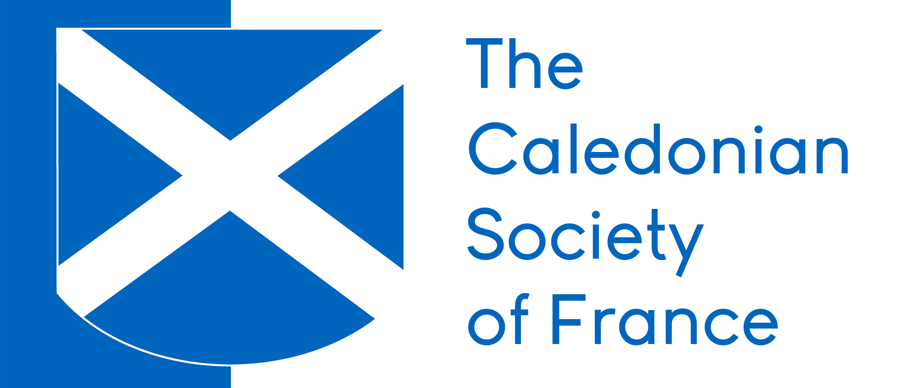

Booking Form - St Andrew’s Night - 2019

Name(s) _________________________________________________________________________
__________________________________________________________________________________
__________________________________________________________________________________
__________________________________________________________________________________
Address _ __________________
____________ _____________________________________
__________________________________________________________________________________
__________________________________________________________________________________
__________________________________________________________________________________
Telephone _______________________________________________________________________
Mobile phone ____________________________________________________________________
e-mail ___________________________________________________________________________
Vegetarian option(s) for ______________ person / people Vegan option(s) for __________________ person / people
Enclosed a cheque to the amount of € for guest(s) and made payable to “The Caledonian Society of France”.
This application form plus the corresponding remittance should be sent to Patrick Shuttlewood, Secretary – The Caledonian Society of France, 7 rue des Pierres, 92190 Meudon.
Members and friends are reminded that bookings must be made by Friday 22nd November 2019 at midday at the very latest and that no refunds can be made after that date.
Guests will be seated at round tables of ten and are invited to indicate with whom they wish to be seated.

