WEEK MENU
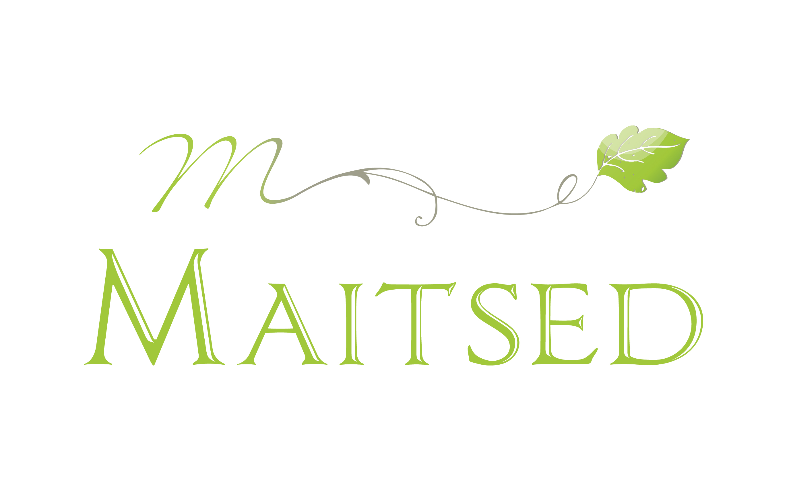
September 25-29, 2023

DAY | BREAKFAST | LUNCH | DINNER
MONDAY | Barley-flake porridge, jam, milk  M/V: Barley-flake porridge with vegan milk | Chicken sauce (P), buckwheat, cabbage and fresh cucumber salad, black bread, apple  M: Sauce of soya milk, buckwheat, salad  V : Vegetable stew, buckwheat | Warm tomato and cheese sandwich  M: Tomato sandwich  V: Tomato and vegan cheese sandwich
TUESDAY | Four-cereal porrige, jam, milk  M/V: Four-cereal porridge with vegan milk | Indian-style soup with turkey(P/M), cucumber sandwich, kohlrabi snack  V: Indian-style soup | Vegetable pie on oat bottom (P), flavored water  V/M: Fruit salad
WEDNESDAY | Milk and macaroni soup, ham sandwich  M/V: Macaroni soup with vegan milk | Paella with vegetables (V/M/P), cold sauce with dill, carrot and pumpkin seed salad, black bread, kefir, pear | Vegetable and lentil soup (V), black bread
THURSDAY | Rice porridge, fresh jam, milk  M/V: Rice porridge with vegan milk | Borsch (M), sour cream, black bread, water melon, turnip snack  P/V: Beet and vegetable soup | Mashed potatoes and pumpkin (P), black bread  V/M: Mashed potatoes and pumpkin
FRIDAY | Omelet with cheese and ham, bread and butter  M/V: Rye porridge with vegan milk | Polish chicken sauce (P), baked potatoes, black bread, Chinese cabbage and carrot salad, flavored water with berries, plum  M: Fish sauce with oat cream, potatoes, salad  V: Roasted vegetables, potatoes | Carrot pie (P), milk, banana  V/M: Baked apples, banana
M- milk free, incl lactose free (does not contain casein) prepared without milk or with vegan milk
P- pork free
V- vegan

