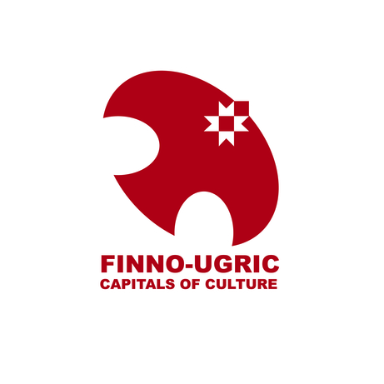

APPLICATION FORM: FINNO-UGRIC CAPITAL OF CULTURE 2025:
TITULAR LOCATION
- Name of the location that your organization is nominating for the title „Finno-Ugric Capital of Culture 2025“ (i.e., titular location)

- Type (city, town, village, region, ... )

- Population

- Which Finno-Ugric peoples are represented in the location (provide estimates of population size by ethnic groups)?

- (Key) educational institutions (list names)

- (Key) cultural institutions (list names)

- Accommodation establishments (number of establishments, total number of beds)

- Transportation infrastructure (air, railway, road, etc)

- Additional key infrastructure / resources

APPLICANT
Contact Information
- Name of Applicant (Organization)

- Mailing address

- Phone

- E-mail

- Website (URL)

- Contact Person

Organizational Profile
- Legal entity (NGO, municipality, regional administration, etc.)

- Organizational mission / objective

- Principal activities

- Number of employees (members)

Past Experience
- Describe your organization’s experience in implementing cultural and creative projects.

- Describe how your organization has participated in / contributed to the Finno-Ugric collaboration and civic movement.

OBJECTIVES
- What are the the three principal goals that your organization wants to accomplish by participating in the Finno-Ugric Capitals of Culture programme?
- Who are the key target audiences of the Capital of Culture year?
PROGRAMME
- What is the leading theme of the Finno-Ugric Capital of Culture 2025 programme?

- How many official Capital of Culture events do you plan to hold during the year?

- How many people do you expect to attend the Capital of Culture year programme?

- What geographic and administrative area(s) will the Capital of Culture programme cover? (the area can extend beyond the titular location)?

- What do you propose as the flagship event of the Capital of Culture year? Explain how this event would be of interest to the wider Finno-Ugric world and external international audiences.

- Briefly describe other key events / projects to be included in the official programme of the Capital of Culture year (max 5 events/projects). Describe the type of project (e.g., cultural event / festival, infrastructure development, training programmes, conferences, etc. ), month/date, target audiences, expected number of participants?
- Describe how the Capital of Culture programme will be administered (e.g., which organizations or individuals will be represented in the Organizing Committee).

- What do you expect to be the total budget of the Capital of Culture year?

- How does your organization expect to finance the Capital of Culture year programme?

- How do you estimate the chances of obtaining the expected level of financing in case your region wins the title of Finno-Ugric Capital of Culture 2025? (feel free to include letters of support from potential donors in the Appendices).

PARTNERS
- Which additional organizations and key individuals do you expect to engage as partners of the Capital of Culture year? (In particular, we are looking for a working partnership between civil society and local/regional authorities).

SUSTAINABILITY
- What will be the sustainable impact of the Capital of Culture year in your region after 2025? How will it improve the cultural and/or socio-economic environment in the titular location and the wider region?

APPENDICES
- Any materials that would support and strengthen your application, e.g., letters of support from partners and financing commitments from sponsors/donors.

- Internet links to visual, audio and video materials supporting your application

